
New Faculty Handbook

Your journey as a Cambrian educator
Table of Contents
Land acknowledgement 4
A welcome from our President 5
Welcome from our Vice President, Academic 6
How to use this handbook 7
Your journey as a Cambrian educator 7
Stage 1: Joining the Cambrian community 8
We are so excited that you’re here! 8
About Cambrian College 10
Your role as a Cambrian educator 11
Our students at a glance 12
Teaching is shared responsibility 13
Looking ahead to the next stage 15
Stage 2: Preparing for your first semester at Cambrian 16
Your first semester roadmap 17
Understanding your teaching assignment 17
Access your institutional accounts 19
Become familiar with campus spaces 20
Preparing your course 21
Set up your Moodle shell 22
Review accommodation information 23
Complete required training 25
Common first semester experiences 26
Your next stage 28
Stage 3: Teaching at Cambrian 29
Teaching begins with our learners 29
Creating inclusive learning environments 31
Connecting learning to professional practice 31
Encouraging curiosity and innovation 33
Building relationships with students 33
Your next stage 36
Stage 4: Understanding your learners 37
Every learner has a story 37
Supporting student readiness 38
Accessibility and academic accommodations 39
Student wellbeing 40
Academic integrity 41
Knowing when to refer students to additional supports and services 42
Your next stage 44
Stage 5: Designing learning experiences 45
Course outlines 45
Understanding learning outcomes and objectives 47
Learning objectives support the outcomes 47
Constructive alignment 50
The syllabus as a learning roadmap 50
Planning learning experiences 53
Assessment and feedback 53
Designing assessments with integrity in mind 54
Educational technology 54
Responsible use of artificial intelligence 55
Your next stage 58
Stage 6: Growing as an educator 59
Reflective practice 59
Reflect 61
Professional learning 62
Scholarship and research 63
Partnering with students 63
Partnering with colleagues 63
Partnering with industry and community 63
Areas of scholarship 64
Sharing your work 64
Faculty performance review 65
Professional Development Leaves 67
Teaching as a career 69
Your journey continues 69
Welcome to the Cambrian teaching community! 70

Land acknowledgement

Image of forest and river by Skyler Ewing
Land acknowledgements are one part of broader national efforts toward reconciliation, relationship-building, and increased awareness of Indigenous histories, perspectives, and experiences in Canada. They recognize the ongoing relationship between Indigenous Peoples and the land, as well as the impacts of colonization and residential schools.
The official institutional land acknowledgement is used at important public events and gatherings:
We acknowledge and respect that we are on the traditional lands of the Anishnaabe People of Turtle Island and proudly recognize our local host, Atikameksheng Anishnawbek. We also recognize the contributions of Wahnapitae First Nation and the Métis Nation of Ontario.”
Faculty may choose to incorporate land acknowledgements or discussions related to Indigenous perspectives into their teaching practice where appropriate and relevant to their discipline and learning environment.
Faculty who are interested in learning more about Indigenous education, cultural awareness, and Indigenous student supports are encouraged to connect with the Wabnode Centre for Indigenous Services.
Further reading: Historical and Contemporary Realities: Movement Towards Reconciliation

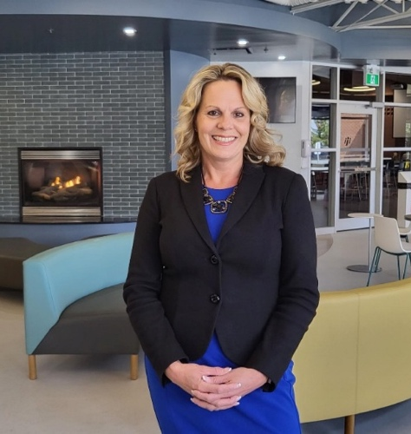
A welcome from our President
Dear New Faculty,
Welcome to Cambrian College. We are so glad to have you as part of our team. You are joining a dynamic, exciting campus community, and you are playing a direct role in shaping the lives and careers of students. That is incredibly rewarding work.
Cambrian has a long, proud tradition in the communities where our employees and graduates live and work; first here at home in Greater Sudbury and then spreading out across Canada and to more than 90 countries around the world.
President, Kristine Morrissey
Cambrian graduates are known for their high levels of skill and leadership. Our graduates perform so well, because they have been taught so well. Faculty like you, working with our support staff and administration, have made significant investments in the lives of our students. And it shows.
In our 2025-30 strategic plan, our number one goal is to deliver education that fosters creativity, resilience, and personal growth. Our second strategic goal is to create a warm, inclusive experience that strengthens our vibrant campus culture. Our third goal is to forge strategic regional and global partnerships that fuel recruitment, unlock learning success, and accelerate innovation and productivity.
To fulfil all these goals, we are not just investing in our students: we are investing in you. This is also a strategic priority at Cambrian. We have made it our mission to empower you for your career success, by fostering an inclusive, high-performing team environment so that you can thrive in your role as a faculty member. That includes building our capacity, and in turn, your capacity to participate in projects with global reach, innovative approaches to teaching and learning, and applied research.
At Cambrian, this campus culture and commitment to excellence is one of our strongest features. It is truly a selling point for students and employees alike. We are professional but personable, we say hi to each other in the hallways, and we personally walk new students and employees to where they need to go if they’re not sure, so they feel right at home among friends.
That is the Cambrian difference. We believe this campus culture is what makes us so unique. We’re confident you will feel that too.
Let this handbook be one of the tools you call upon often to help you during your time with us. This handbook will serve as your guide to the supports that are available. Refer to this guide often, especially in the early days of your teaching career with us. Know that we are here to support you in any way we can.
We want you to be well-prepared and well-supported as you begin your teaching career with us. When you succeed, our students succeed.
Thank you for choosing Cambrian College. Welcome to the community!

Kristine Morrissey
President, Cambrian College

Welcome from our Vice President, Academic

Dear Faculty,
Welcome to Cambrian College! I am delighted that you are joining us, and I look forward to the knowledge, expertise, and fresh perspective that each of you will bring.
At Cambrian, we take immense pride in our commitment to excellence in education and our dedication to providing an environment where students can thrive and succeed. You are joining a very diverse community that welcomes students to our campus from across the province, the country and from around the world. We value this diversity as it allows us all to grow and learn as educators, united in our commitment to student success.
Vice President Academic, Janice Clarke
As a faculty member, you play a vital role in shaping the future of our students and contributing to the academic community as a whole. Your passion for teaching, innovative ideas, and dedication to fostering an engaging learning experience will undoubtedly contribute to our shared mission of empowering students to reach their full potential.
As you settle into your role, you will find ample opportunities for collaboration, professional development, and personal growth. Our goal is to ensure that you have access to the services, support, and tools that you need to allow you to excel as a member of our faculty. We fully believe that our students’ success stems from having the opportunity to learn with and from the best. This handbook is designed to help you become more familiar with our college’s policies and procedures and is filled with information related to teaching and learning at Cambrian that we feel will help contribute to your experience at the College and ultimately to our students’ success.
I wish you all the best as you begin and advance your teaching career at Cambrian College.

Janice Clarke,
Vice-President, Academic

How to use this handbook
Beginning a new teaching role is an exciting opportunity. It is also a time filled with new information, new responsibilities, and many questions.
This handbook has been designed to support you throughout your first semester and beyond. Rather than serving as a collection of policies or procedures, it is intended to be a practical guide that helps you build confidence as an educator at Cambrian College.
Whether you are joining Cambrian as a partial-load, sessional, or full-time faculty member, you are now part of a community dedicated to helping students succeed. While responsibilities and opportunities may differ by appointment type, every faculty member plays an important role in creating engaging learning experiences for our students.
You do not need to read this handbook from beginning to end in a single sitting. Instead, think of it as a companion that you can return to throughout your teaching journey.
Each stage builds on the previous one, moving from preparing for your first semester to developing your teaching practice and continuing your professional growth.
Throughout the handbook you will find practical tips, examples, reflection questions, and suggestions to help you apply what you learn in your own teaching.
Teaching expertise develops over time through experience, reflection, collaboration, and continuous learning. Wherever you are in your teaching journey, we hope this handbook helps you feel supported, connected, and confident as a member of the Cambrian teaching community.

Your journey as a Cambrian educator

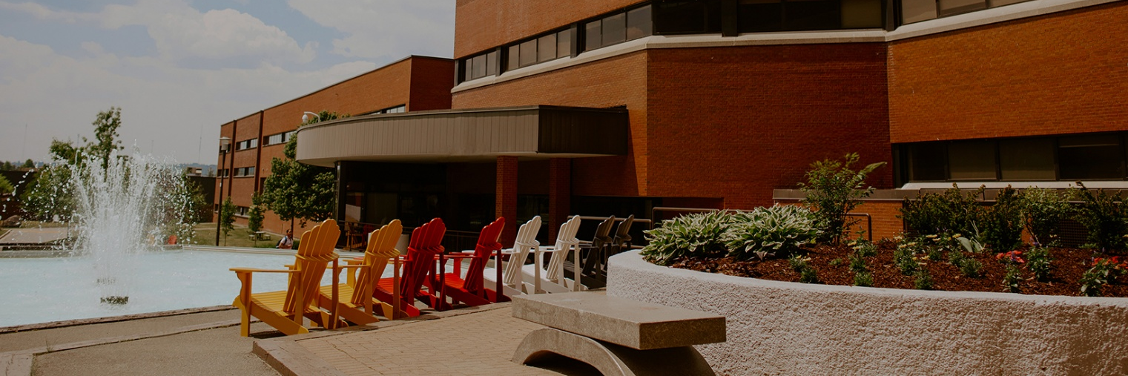
Stage 1: Joining the Cambrian community
At this stage in your journey...
You've accepted a teaching position at Cambrian College and are becoming part of a new academic community. There is a lot to learn, and it's normal to have questions about your role, the College, and what to expect. Before thinking about lesson plans or assessments, it's important to understand who we are, what we value, and how you contribute to the success of our students.
This stage introduces the Cambrian community and helps you begin your journey with a sense of purpose, belonging, and connection.

We are so excited that you’re here!
Beginning a new teaching role can feel both exciting and overwhelming, especially during your first semester. Whether you are new to teaching, transitioning from industry into higher education, or joining Cambrian from another institution, this handbook was designed to support you as you begin your journey with us.
At Cambrian, faculty play an important role in shaping the student experience. The learning environments you create, the relationships you build with students, and the expertise you bring to the classroom contribute directly to student confidence, belonging, and success.

We encourage you to ask questions, connect with colleagues, seek support early, and take advantage of the professional learning opportunities available to you. You are joining a community that values collaboration, innovation, inclusion, and student success.


About Cambrian College
Understanding the institution, its mission, and its students helps you in your faculty role connect your teaching to the broader educational experience and strategic priorities of the College.
Cambrian College is the largest college in northeastern Ontario and serves thousands of full-time, part-time, domestic, and international students each year. Since opening in 1967, Cambrian has built a strong reputation for applied learning, industry partnerships, student support, and community engagement.
Cambrian College fountain

As a faculty member, you contribute directly to these priorities through your teaching, mentorship, curriculum expertise, and support of student learning.
Do you want to know more? Visit:
About Cambrian
Strategic Plan 2025-2030


Your role as a Cambrian educator
Students often remember the educators who challenged, encouraged, and supported them long after they have forgotten individual lessons.
As a faculty member, you help students build knowledge, confidence, professional identity, and the skills needed for lifelong learning. Faculty responsibilities extend beyond delivering course content.
As an educator, you will:

Teaching is both an academic and a professional responsibility.

Our students at a glance
Understanding who your students are helps you create learning environments that are engaging, inclusive, and responsive to student needs.
Cambrian students represent a diverse range of experiences, backgrounds, identities, and educational pathways.

Each student brings unique strengths, experiences, and goals to the learning environment.

Teaching is shared responsibility
You are not expected to navigate your first semester alone!
Faculty work alongside Chairs, Program Coordinators, Student Success Services, Accessibility Services, librarians, educational developers, technicians, counsellors, and many others to create a positive learning experience.
You are never expected to navigate challenges alone. Knowing when to seek support is an important part of being an effective educator.
Many successful faculty members continue refining their teaching practices throughout their careers. Asking questions, seeking feedback, and accessing support are normal parts of professional growth in higher education.
If you are unsure where to start, begin with your Chair, Program Coordinator, or the Teaching and Learning Innovation Hub. They can help connect you with the appropriate resources and support.

COMMON CHALLENGE
Many new faculty believe they need to have every lesson, activity, and assessment perfected before the semester begins.
In reality, students benefit most from clear communication, thoughtful organization, responsiveness, and a willingness to adapt as the semester progresses.

Reflect
Think about an educator who had a positive impact on your own learning. What did they do that made you feel supported, challenged, or inspired? As you begin your teaching journey, what kind of learning experience do you hope your students will remember?

Looking ahead to the next stage
Now that you've been introduced to the Cambrian community, the next stage focuses on preparing for your first semester. You'll learn how to navigate your teaching assignment, organize your course, prepare for your first class, and establish a strong foundation for a successful semester.
After completing this stage, you should be able to...

Stage 2: Preparing for your first semester at Cambrian
At this stage in your journey...
The first day of classes is approaching, and your focus shifts from becoming familiar with the College to preparing for your students. You'll be organizing your course, learning new systems, becoming familiar with your teaching spaces, and planning your first classes.
You don't need to have every answer before the semester begins. Your goal is to build a strong foundation that allows you to begin teaching with confidence while recognizing that your skills and experience will continue to grow throughout the semester.
Teaching your first course can feel exciting, rewarding, and, at times, overwhelming. During your first semester, you will be learning new systems, meeting students, preparing lessons, grading assessments, and balancing many competing priorities.
The good news is that you are not expected to figure everything out on your own. This stage will help you establish a strong foundation before classes begin and provide practical guidance for navigating the first few weeks of the semester.
Remember that successful teaching is built over time. Focus on creating an organized, welcoming, and engaging learning experience for your students, and allow yourself the opportunity to grow with each class you teach.

Your first semester roadmap
Although every semester is unique, many faculty experience similar milestones. The table below highlights common priorities throughout the semester.

Understanding your teaching assignment
Taking time to become familiar with your teaching assignment, resources, and support network will make the beginning of the semester significantly smoother.
Before planning your course, it is important to understand the curriculum, program expectations, and available resources.

DID YOU KNOW?
Many experienced faculty describe their first semester as one of the steepest learning curves of their careers. Feeling uncertain is a natural part of becoming an educator.
Upon hire, you should receive details about your teaching assignment from your Chair, including:

If you are teaching in a multi-section course, connect with other faculty teaching the same course to discuss:

Collaboration early in the semester often reduces confusion later.

In practice
Connect with other faculty teaching the same course whenever possible. Conversations about assessments, pacing, common student challenges, and learning activities can save considerable time and help ensure consistency across sections.

Where to get help
Your Chair, Program Coordinator, and administrative support staff should be your first point of contact for program-specific questions.

Access your institutional accounts
Several institutional systems support teaching, communication, grading, payroll, and student information.
As a Cambrian faculty member, you will regularly use the following platforms:

In practice
If you are teaching in a classroom that you have never used before, visit it before your first class. Practice logging into the computer, projecting materials, and testing audio if needed.

Where to get help
Contact IT Service Desk if you experience difficulties accessing any institutional systems. Contact the Hub team for training on any platform.
Full-time faculty will also receive the following from their department:

Become familiar with campus spaces
Knowing where you are teaching and where key services are located can reduce first-week stress and help you support students more effectively.

If you are teaching in a FLEX or technology-enhanced classroom, consider requesting training with the Hub’s Senior Educational Technology Specialist before your first class.
Familiarity with physical spaces helps reduce first-day stress and improves confidence when supporting students.

COMMON CHALLENGE
Technology problems often occur when instructors enter a classroom for the first time only minutes before class begins. A brief classroom visit before the semester starts can prevent many first-day frustrations.

Preparing your course
Students rely on faculty to provide clear direction and organized learning experiences from the start of the semester.
Before teaching begins, review:

Course outlines identify the approved learning outcomes and assessment framework for the course. These documents should guide your course planning and instructional decisions throughout the semester.

In practice
When planning your course, begin with the learning outcomes. Consider:
- What students need to learn (e.g., learning outcomes in the course outline)
- How they will demonstrate learning (e.g., through ungraded and graded assessments)
- What activities will support success (e.g., through in-class activities)
Starting with outcomes helps create alignment between instruction, assessment, and learning activities.

Where to get help
The Teaching and Learning Innovation Hub can assist with course planning, assessment design, and instructional strategies.

Set up your Moodle shell
For many students, Moodle serves as the primary online home for the course.
Moodle is a Learning Management System (LMS), which is used to support, organize, deliver, and manage teaching and learning activities for your courses.
Students use Moodle to:

At minimum, students should be able to locate:

In practice

Students value consistency and organization. A clear Moodle course often reduces confusion and unnecessary emails.
Learn how to use Moodle on the Hub’s website or reach out the Hub team directly.

Review accommodation information
Some students require accommodations to ensure equitable access to learning.
Approved academic accommodations through the Glenn Crombie Centre for Accessibility, Counselling, and Wellness (GCC).
Accommodation letters provide information about approved supports that help reduce barriers to learning and assessment. Common accommodations may include:

In practice
Faculty are responsible for reviewing and implementing all approved accommodations.
Faculty typically receive an email indicating that a student in one of their courses has been identified with an accommodation. Faculty must log into myCambrian and go to the Faculty Dashboard to view the letter within the Clockwork platform. In Clockwork, faculty must acknowledge receipt of the accommodation letter.

- Click “Working here” ⇒ “Faculty Dashboard”
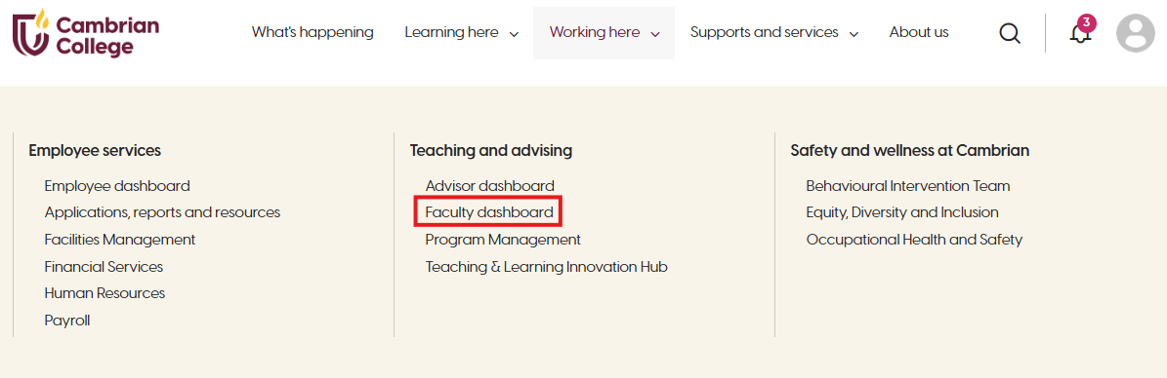
- Click “Clockwork: accommodations” in the left-hand menu.
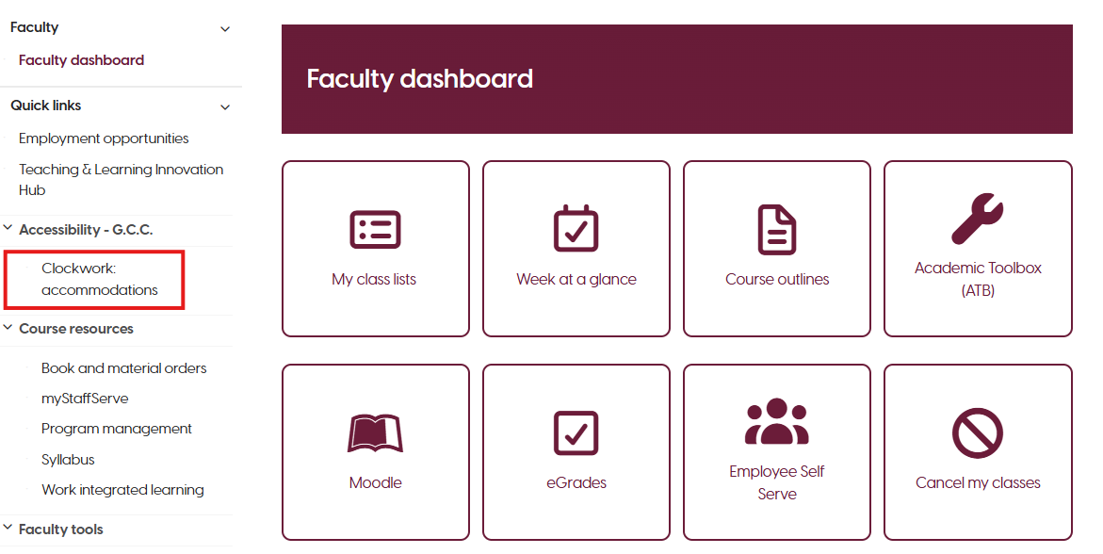
If you have questions about accommodations or how to implement them, connect with the Glenn Crombie Centre for guidance. You can also learn more about Student Accommodations on the Hub website.

Where to get help
Contact the Glenn Crombie Center for Accessibility, Counselling and Wellness (GCC) if you have questions about implementing accommodations. You can also view the Student Accommodations page on the Hub’s website for general information.

Complete required training
New faculty are required to complete several institutional training modules during onboarding.
These may include:

You can find your required HR trainings in myCambrian.
- Click “Working here” ⇒ “Human Resources”
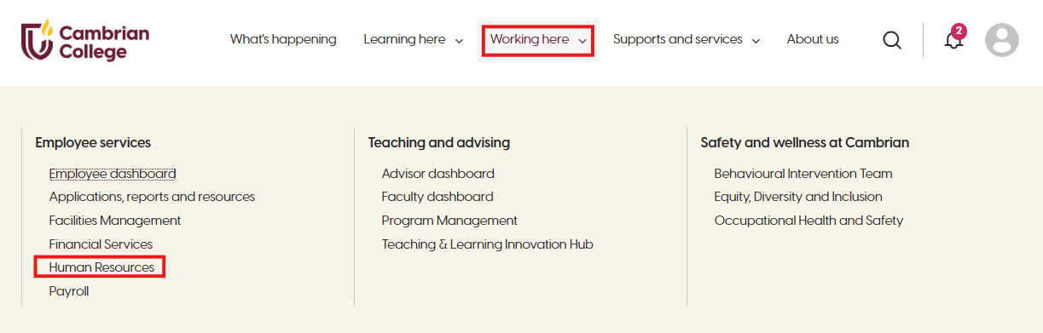

- Then, select “Mandatory training”
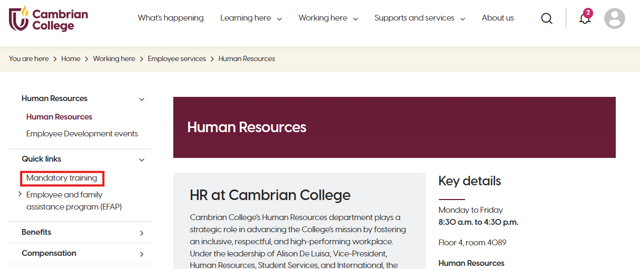

Where to get help
Human Resources can provide information regarding current training requirements and deadlines.

Common first semester experiences

These experiences are normal! Teaching expertise develops gradually through experience, reflection, feedback, and professional learning.

Where to get help
Support is available throughout your first semester and entire teaching journey.

Asking for help early often prevents larger challenges later in the semester.

NEW FACULTY TIP
You are not expected to have every answer immediately. Seeking support, asking questions, and learning alongside colleagues are normal parts of becoming an effective educator.

Your next stage
Preparing your course is only the beginning. The next stage explores what effective teaching looks like at Cambrian College and introduces the principles that guide engaging, inclusive, and meaningful learning experiences.
After completing this stage, you should be able to...

Stage 3: Teaching at Cambrian
At this stage in your journey...
Now that you're preparing to teach, it's time to think beyond logistics and consider what effective teaching looks like at Cambrian College. Great teaching is more than delivering content. It's about creating engaging learning experiences that help students develop knowledge, skills, confidence, and professional identity.
This stage explores the principles that guide teaching at Cambrian and provides practical ideas for creating learning experiences that are learner-centred, inclusive, applied, and meaningful.
Teaching is one of the most meaningful ways we contribute to student success. Every class, conversation, assessment, and learning activity shapes not only what students learn, but also how they develop confidence, professional identity, and the skills they will carry into their future careers.
While every program and discipline is unique, effective teaching at Cambrian is guided by a shared commitment to creating engaging, inclusive, and applied learning experiences that prepare students for success beyond the classroom.
Every learning activity, discussion, demonstration, and assessment should have a clear purpose. Students are more engaged when they understand not only what they are learning, but also why it matters.
Purposeful teaching begins by asking: "What do I want students to understand, experience, or be able to do as a result of this learning?"
This stage explores the principles that guide teaching at Cambrian College and introduces practical approaches that support meaningful learning.

Teaching begins with our learners
Every learner arrives with different experiences, strengths, motivations, and goals. Effective teaching begins by understanding who our students are and creating learning experiences that help them succeed.
Learner-centred teaching places learning at the heart of every instructional decision. Rather than focusing solely on what will be taught, faculty also consider how students learn, how they engage with course material, and how they demonstrate their learning.
Learner-centred teaching encourages students to become active participants in the learning process through discussion, practice, reflection, collaboration, and problem-solving. This approach creates meaningful opportunities for our learners to engage deeply with course content while maintaining high standards.

In practice
Learner-centred teaching might include:


NEW FACULTY TIP
Students are more engaged when they understand why they are learning something, not only what they are learning.

Creating inclusive learning environments
Since learners bring diverse identities, experiences, abilities, cultures, and educational backgrounds into every classroom, creating learning environments where all our learners have equitable opportunities to succeed is an important, shared responsibility.
Inclusive teaching means designing learning experiences that recognize and respect learner diversity while reducing unnecessary barriers to participation.
Accessibility benefits all learners. Clear communication, organized course materials, varied learning activities, and thoughtful assessment design support student success across the classroom.
Faculty are also responsible for implementing approved academic accommodations and maintaining student confidentiality.

In practice
Inclusive teaching may involve:

Connecting learning to professional practice
Cambrian College prepares learners for careers, professions, and lifelong learning. Learners develop deeper understanding when they can apply classroom knowledge to authentic situations.
Applied learning is a defining characteristic of a college education. Across programs, students benefit from opportunities to practice skills, solve problems, and apply concepts in realistic contexts.

Depending on the discipline, applied learning may include:

These experiences help students develop confidence while strengthening the connection between theory and practice.

In practice
Ask yourself: "How can learners in this course apply what they are learning rather than simply recall information?"
Learning activities that encourage learners to analyze, create, evaluate, demonstrate, or solve authentic problems often promote deeper understanding than activities focused solely on remembering information.

Encouraging curiosity and innovation
The world our students are entering continues to change. Technology, workplaces, and professional practices evolve, and teaching must evolve alongside them.
Innovation is not about using the newest technology. It is about finding better ways to support learning. Innovation may involve:

Begin with the learning, not the technology. Every instructional strategy or digital tool should have a clear educational purpose.

Building relationships with students
Positive relationships contribute to student engagement, confidence, and persistence.
Students are more likely to participate, ask questions, and seek support when they feel respected and welcomed in the classroom.

Building relationships does not mean lowering expectations or becoming friends with students. Professional relationships are built through:

Students appreciate faculty who are organized, prepared, and genuinely interested in their learning.

Where to get help
Teaching is a collaborative profession, and support is available throughout your career.
The Teaching and Learning Innovation Hub can support you with:

Whether you are developing a new course, exploring innovative teaching approaches, or looking for fresh ideas to engage students, the Hub is here to support your growth as an educator.

Reflect
Think about the educator who had the greatest influence on your own learning. What did they do that made you feel engaged, challenged, or supported? How might those same qualities influence the learning environment you create for your students?

Your next stage
Every classroom is unique because every student is unique.
In the next stage, you'll explore the diverse backgrounds, experiences, strengths, and challenges that Cambrian students bring to the classroom and consider how understanding your learners can help you create more meaningful and supportive learning experiences.
After completing this stage, you should be able to...

Stage 4: Understanding your learners
At this stage in your journey...
As you begin teaching, you'll quickly discover that no two classrooms are the same. Every student brings different experiences, strengths, motivations, and challenges that influence how they learn and engage.
Understanding your learners is an essential part of effective teaching. It helps you create learning environments that are welcoming, inclusive, and responsive while maintaining high academic expectations for every student.
This stage introduces the diversity of Cambrian's learners, explores common barriers to learning, and highlights your role in fostering student success.


Every learner has a story
Students arrive at Cambrian College with a wide range of experiences, identities, strengths, goals, and support needs. Understanding the diversity of student experiences can help faculty create more effective, inclusive, and supportive learning environments.
Many students are balancing academic responsibilities alongside employment, caregiving, financial pressures, commuting, housing concerns, health challenges, or major life transitions. Some students enter college directly from high school, while others may be returning to education after years in the workforce.
Students may also have different levels of confidence, academic preparation, digital literacy, and familiarity with post-secondary expectations. These differences influence how students participate, communicate, manage workload, and engage with learning.
Faculty are not expected to solve every challenge students face. However, understanding the broader student experience can help faculty respond thoughtfully, communicate clearly, and connect students with appropriate supports when needed.
No two students enter your classroom with the same educational background or life experiences. Recognizing this diversity helps faculty create learning environments that are inclusive, supportive, and responsive while maintaining high academic expectations.
Cambrian students represent many different pathways into post-secondary education. Our student population includes students entering directly from high school, mature learners, International students, Indigenous students, first-generation college students, apprentices, students changing careers or returning to education after time in the workforce, dual credit students, and Academic Upgrading students.
Students also bring diverse:

These differences enrich classroom discussions and create opportunities for collaborative learning.

In practice
Avoid making assumptions about what students already know or have experienced. Explain expectations clearly, provide examples when introducing unfamiliar concepts, and encourage questions and sharing of personal/professional experiences throughout the semester.

Supporting student readiness
Students begin college with varying levels of academic preparation, confidence, and learning strategies. Supporting this transition helps students build the skills they need to succeed.
Learners vary in their writing and communication skills, study habits, digital literacy, time management skills, confidence levels, critical thinking skills. and familiarity with college expectations.
Some students adapt quickly, while others require additional time and support to develop effective learning strategies.

In practice
Faculty can support student transition by:

Accessibility and academic accommodations
Cambrian College is committed to creating equitable learning opportunities for all students.
Some students receive academic accommodations through the Glenn Crombie Centre for Accessibility, Counselling, and Wellness.
Academic accommodations reduce barriers to learning while maintaining the essential learning outcomes of the course.
Examples of accommodations may include:

Faculty are responsible for reviewing accommodation letters, implementing approved accommodations, and maintaining student confidentiality.

In practice
If you have questions about implementing an accommodation, contact the Glenn Crombie Centre. Faculty are not expected to determine accommodations independently.

Student wellbeing
Learning is influenced by physical, emotional, social, and mental wellbeing.
Students who experience personal challenges may also experience difficulties with attendance, participation, or academic performance.

Faculty are not expected to provide counselling or solve personal problems for students. Your role is to notice concerns, respond with empathy, and connect students with appropriate supports when needed.

In practice
You might notice a student who:

A 1-1 conversation with the student and referral to appropriate services can make a significant difference. You can refer students to the GCC’s counseling services, the Learning Centre for learning strategies and tutoring supports, or the Academic Success Centre for support with academic progression.

Academic integrity
Academic integrity is fundamental to teaching, learning, and professional practice. It helps ensure that grades accurately reflect student learning and that students develop the ethical habits expected in their future careers.
Faculty support academic integrity by:

When concerns arise, follow the Academic Integrity Policy and Academic Integrity Violation Procedure.
The Academic Integrity Office is available to support faculty with questions about policy, procedures, assessment design, and educational strategies that promote academic integrity.

In practice
The strongest academic integrity strategy is prevention. Students are more likely to demonstrate integrity when expectations are communicated clearly and assessments are intentionally designed.

DID YOU KNOW?
Many cases of academic misconduct result from confusion rather than intentional dishonesty. Clear expectations, opportunities for practice, and regular conversations about integrity can help prevent problems before they occur.

Knowing when to refer students to additional supports and services
Faculty interact with students regularly and may notice early signs that a student is struggling.
You may become concerned when a student:

COMMON CHALLENGE
Remember that supporting students is a shared institutional responsibility. Your role is to identify concerns, respond with empathy, and connect students with the professionals and services best equipped to help.

In practice
When appropriate:

Where to get help
Students have access to many supports and services across the College.

You are never expected to navigate complex student situations alone. When in doubt, ask questions and seek guidance.

Your next stage
Understanding your learners is the foundation of effective teaching. The next stage explores how to intentionally design learning experiences that help those students achieve meaningful learning outcomes and prepare for success beyond the classroom.
After completing this stage, you should be able to...

Stage 5: Designing learning experiences
At this stage in your journey...
You've learned about your students and the principles that guide teaching at Cambrian. Now it's time to intentionally design learning experiences that help students achieve meaningful outcomes.
Rather than asking, "What should I teach next week?" you'll begin asking, "How can I design learning that helps students succeed?" This stage introduces practical approaches to planning courses, developing learning objectives, designing assessments, and creating engaging learning experiences that support student success.
Planning a course involves much more than organizing weekly topics or creating assessments. Thoughtful course planning helps students understand what they are learning, why it matters, and how each learning activity contributes to their success.
Effective course planning begins with the end in mind. Every course should provide students with opportunities to achieve the intended learning outcomes through meaningful learning experiences and assessments that accurately measure their learning.
This section introduces the key components of course planning at Cambrian College and offers practical guidance for creating engaging, organized, and student-centred learning experiences.

Course outlines
The course outline is the official curriculum document for every course at Cambrian College. It establishes the approved learning outcomes, assessment framework, and curriculum requirements for the academic year. The course outline serves as the foundation for all course planning decisions.

Course outlines include:

Course outlines undergo an institutional approval process and are published annually. Once approved, they remain consistent throughout the academic year to ensure all students enrolled in the course receive a comparable learning experience.
Faculty should use the course outline to guide the development of:

In practice
Before planning lessons, read the course outline carefully. The semester typically has 14 weeks, so your lessons should be planned out to ensure all learning outcomes are covered and assessed before the end of the semester.

Where to get help
The Teaching and Learning Innovation Hub can assist with interpreting course outlines, curriculum alignment, and course planning. You can view a read a course outline using the Hub’s Anatomy of a Course Outline.

Understanding learning outcomes and objectives
Course learning outcomes describe what students are expected to know, do, or demonstrate by the end of the course and guide decisions about teaching, learning activities, and assessment. Learning objectives describe the steps learners will take to get there.
Understanding how to interpret course learning outcomes will help you plan lessons, develop meaningful learning experiences, and ensure students have opportunities to achieve the intended outcomes.
Each course outline contains a series of course learning outcomes (CLOs). These outcomes represent the knowledge, skills, and abilities students are expected to demonstrate upon successful completion of the course.
Course learning outcomes are intentionally broad. They describe the overall learning students should achieve throughout the course rather than what will be covered in a single class or week.
For example, a course learning outcome might ask students to:
"Apply principles of therapeutic communication when interacting with clients."
Students are not expected to achieve this outcome after one lesson. Instead, they develop the knowledge and skills over multiple weeks through learning activities, practice, feedback, and assessment. Your role as a faculty is to ensure that your lessons provide students with scaffolded knowledge and practice activities that supports the development of those skills and/or abilities.

Learning objectives support the outcomes
While course learning outcomes describe the overall expectations for the course, learning objectives identify the smaller steps that help students achieve those outcomes.
Learning objectives are typically developed for individual classes, modules, or weeks and describe what students should know or be able to do by the end of that learning experience.

Example: Building towards a course learning outcome
The example below illustrates how a single course learning outcome can be supported through a series of learning objectives that are intentionally scaffolded over multiple classes.

Course learning outcome and objectives in action

The outcome and related objectives represent the overall learning students should be able to demonstrate by the end of the course. Students are not expected to achieve this outcome in a single lesson. Instead, learning develops gradually through smaller learning objectives that build on one another.

Notice how the learning progresses.

Each lesson builds on the previous one, helping students develop the knowledge, skills, and confidence needed to successfully achieve the course learning outcome by the end of the course.
When planning your course, think of learning as a progression rather than a series of independent classes. Each lesson should intentionally build on previous learning and prepare students for the next stage of development. This gradual progression, often referred to as scaffolding, helps students develop confidence while working toward the broader course learning outcomes.

Where to get help
If you have questions about interpreting course learning outcomes or planning learning experiences that support them, speak with the Teaching and Learning Innovation Hub.

Constructive alignment
Students learn more effectively when learning outcomes, learning activities, and assessments all support one another.
Strong course design aligns three elements:

When these three elements are aligned, students have multiple opportunities to develop and demonstrate their learning.

In practice
Before introducing a new activity or assessment, ask yourself, "what learning outcome does this support?" If the answer is unclear, consider revising the activity or assessment.

The syllabus as a learning roadmap
Your syllabus is more than a schedule of topics and due dates. It provides students with a roadmap for the learning journey ahead.
A well-designed syllabus helps students understand how individual lessons connect to broader course learning outcomes and prepares them for what is expected throughout the semester.
At Cambrian College, the syllabus includes:

While these elements provide important information, the syllabus also communicates the overall progression of learning throughout the course.
Students should be able to see how one week's learning builds upon the next and how each learning experience contributes to the course learning outcomes.

In practice
When reviewing your syllabus, ask yourself:

Your syllabus should help students understand not only what they will learn, but how their learning develops over the semester.

Example syllabus: Alien Technology 101
Week | Topic | Instructional materials (Lessons) | Learning activities  (Ungraded practice activities) | Assessments (Graded) | Leaning outcomes |  | Learning objectives
One | Course introduction and foundations | Read: Chapter 1 [textbook]  Listen: Episode 4 [podcast] | Class discussion on examples of alien technology in science fiction
Two | Theoretical principles of alien technologies | Read: Chapter 2 [textbook]  Watch: “Alien Technologies Used in Modern Day Film” [YouTube] | Identify and analyze key alien technologies used in film.
Three | Alien propulsion systems | Read: Chapter 5 [textbook]  Watch: “Propulsion Systems: Past, Present, and Future” [YouTube] | Discuss in groups: Compare alien propulsion systems with current human-engineered technologies.
Four | Energy sources and sustainability | Read: Chapter 9 [textbook]  Listen: Episode 29 [podcast] | Group research on alien energy concepts and presentation of findings | Technology analysts report: Due September 20th  Value: 20% |  | CLO 1 | Obj. 1.1, 1.2, 1.3
Review your syllabus regularly throughout the semester and update students if changes become necessary. Students appreciate consistency and advance notice whenever schedules change.

Planning learning experiences
Students learn best when they actively engage with course content rather than simply receiving information.
Effective learning experiences often include opportunities for students to:

Learning experiences should encourage students to think critically rather than simply memorize information.

In practice
Consider balancing short instructor presentations with opportunities for students to apply what they have learned through discussions, demonstrations, activities, or case studies.

DID YOU KNOW?
Research consistently shows that students learn more when they actively engage with course material than when they passively listen to extended lectures.

Assessment and feedback
Assessment provides evidence of student learning and helps students understand their progress toward achieving course outcomes. Effective feedback helps students understand their progress and identify opportunities for improvement.
Effective assessment is aligned with learning outcomes, transparent (clear expectations, instructions, and grading criteria), and timely. Providing meaningful feedback helps students improve their learning before completing future assessments.

In practice
Whenever possible:

Feedback should help students understand both what they did well and where they can continue developing.

Designing assessments with integrity in mind
Assessment is most effective when it measures meaningful learning and encourages students to demonstrate their own knowledge and skills. Thoughtful assessment design also supports academic integrity.
When designing assessments, consider:

Designing authentic assessments helps students focus on learning while reducing opportunities for academic misconduct.

Educational technology
Educational technology can enhance learning by improving communication, engagement, accessibility, and flexibility.
Technology should always support learning outcomes rather than becoming the focus of instruction.

Choose technologies that improve learning and are appropriate for your students and course.

NEW FACULTY TIP
Introducing a new technology requires students to learn both the content and the tool. Whenever possible, keep technology simple, purposeful, and aligned with the learning outcomes.

Responsible use of artificial intelligence
Artificial intelligence (AI) is increasingly influencing teaching, learning, and professional practice across many disciplines. Faculty play an important role in helping students use AI responsibly and ethically.
Expectations regarding AI should be communicated clearly for every assessment. AI should support learning rather than replace student thinking.

Consider communicating the following to your students:

In practice
Rather than asking whether students should use AI, consider asking, "What learning is this assessment intended to measure?" The answer should guide decisions about appropriate AI use.

Where to get help
The Teaching and Learning Innovation Hub can support you with:

Whether you are planning a new course or refining an existing one, the Hub is available to partner with you throughout the process.

COMMON CHALLENGE
New faculty often spend significant time creating detailed lecture slides while spending less time planning how students will actively engage with the material.
Effective learning experiences balance information with opportunities for students to think, discuss, practice, and apply what they are learning.

Your next stage
Every educator continues learning throughout their career. The final stage explores how professional learning, reflection, scholarship, collaboration, and ongoing development can help you continue growing as an educator at Cambrian College.
After completing this stage, you should be able to...

Stage 6: Growing as an educator
At this stage in your journey...
Teaching is a career of continuous learning. Every semester brings new students, new experiences, and new opportunities to refine your practice. As your confidence grows, so do the possibilities for professional learning, scholarship, leadership, and collaboration.
This final stage encourages you to think beyond your first semester and begin shaping the educator you want to become. Whether your path includes curriculum development, applied research, conference presentations, mentoring colleagues, or simply becoming more confident in the classroom, your journey as a Cambrian educator is only beginning.
Teaching is a profession of continuous learning. Every course you teach, every student you support, and every semester you complete contributes to your growth as an educator.
There will always be opportunities to strengthen your practice, explore new ideas, and learn from colleagues.
At Cambrian College, professional growth is supported through reflection, collaboration, scholarship, and ongoing professional learning. You are encouraged to engage with the teaching community, seek feedback, remain current in your discipline, and continually refine your approach to teaching and learning.
This section introduces the many ways faculty can continue developing throughout their careers at Cambrian.

Reflective practice
Reflection is one of the most effective ways to improve teaching.
Taking time to consider what worked well, what challenged students, and what could be improved helps faculty make informed decisions that enhance future learning experiences.
Reflection does not mean striving for perfection. It is about continually learning from experience.
Reflective practice can occur at several different points in your academic year. It may be prompted by:

Reflection may be informal, such as making notes after class, or more structured through peer conversations, teaching portfolios, or professional development activities.

NEW FACULTY TIP
Some of the most significant professional growth begins with a simple question: "What could I learn that would help my students be more successful?"
Answering that question may lead to a new teaching strategy, a conference presentation, an applied research project, a graduate credential, or a professional development leave. Reflection is not simply about looking back. It is about intentionally shaping the next stage of your professional journey.

In Practice
Reflection can become the starting point for professional learning, scholarship (e.g., research activities), or leadership.
For example, after teaching a course for several semesters, you may notice that students consistently struggle with a particular concept or assessment. Rather than simply revising the lesson, you may choose to investigate the issue more deeply by reviewing educational literature, exploring new instructional approaches, or conducting a Scholarship of Teaching and Learning (SoTL) project to better understand student learning.
In another situation, you may recognize that advances in your discipline, new technologies, or changing workplace practices require you to develop new knowledge or skills. This reflection might lead you to attend workshops, pursue additional certifications, participate in conferences, complete graduate studies, or apply for a professional development leave to support more extensive learning or curriculum development.
Reflection can also lead to leadership opportunities, including participating in curriculum renewal, mentoring colleagues, facilitating professional learning, or contributing to institutional initiatives that enhance teaching and learning across the College.
Reflective practice is most valuable when it moves beyond identifying challenges and becomes a catalyst for meaningful action.

Reflect
What aspects of your teaching or professional practice would you like to strengthen over the next few years? What experiences or opportunities might help you achieve those goals?

Professional learning
Teaching continues to evolve as educational research, technology, industries, and student needs change. Ongoing professional learning helps faculty remain current and responsive in their teaching practice.
Professional learning can take many forms, including:

Some of the most valuable professional learning occurs through conversations with colleagues. Sharing ideas, challenges, and experiences helps build confidence, introduces new perspectives, and strengthens teaching across programs.
One way of working with other faculty is through Communities of Practice (CoP). CoPs bring together faculty who share an interest in teaching and learning. These communities create opportunities to exchange ideas, explore emerging topics, and learn from one another in an informal and supportive environment.
- Communities of Practice
Another way to learn alongside colleagues is the Instructional Skills Workshop (ISW). The ISW is an internationally recognized professional development program that helps educators strengthen their instructional practice through active participation, peer feedback, and reflection.
- Instructional Skills Workshop

In practice
Consider identifying one or two teaching goals each semester. Small, intentional changes often lead to meaningful improvements over time.

Scholarship and research
Teaching is strengthened when faculty remain engaged with developments in their disciplines and the broader scholarship of teaching and learning.
Faculty contribute to student learning not only through teaching, but also through scholarship, applied research, and professional engagement. These activities help faculty remain current in their disciplines, strengthen teaching practices, foster innovation, and contribute to the broader communities and industries served by Cambrian College.
Scholarship and research take many forms. Whether you are exploring new teaching strategies, collaborating with industry, presenting at a conference, or engaging students in research projects, these activities enrich both your professional practice and the student learning experience.
Faculty engage in scholarship and research in many ways.

Partnering with students
Students can be valuable partners in scholarship and applied research. Opportunities may include supervising research projects, mentoring capstone experiences, involving students in data collection or analysis, or co-presenting and co-authoring scholarly work.

Partnering with colleagues
Collaborating with faculty from your own or other disciplines can lead to innovative teaching practices, curriculum development, Scholarship of Teaching and Learning (SoTL) projects, or discipline-specific research.

Partnering with industry and community
Applied research often brings faculty together with industry, healthcare organizations, community agencies, and other partners to address real-world challenges. These collaborations strengthen relationships with the community while creating meaningful learning opportunities for students.

COMMON CHALLENGE
New faculty sometimes believe they need to solve every teaching challenge independently. Realistically, experienced faculty regularly exchange ideas, seek advice, and learn from one another. Asking questions is an important part of professional growth.

Areas of scholarship
Faculty may engage in scholarship related to:

Sharing your work
Faculty are encouraged to engage in knowledge mobilization (aka share their scholarship work) through:

Sharing ideas contributes to the broader teaching and professional community while supporting your own growth as an educator.

Where to get help
If you are interested in scholarship or research, speak with your Chair, Dean, the Applied Research Office, or the Teaching and Learning Innovation Hub to learn about available supports, partnerships, funding opportunities, and professional development.

Faculty performance review
The faculty performance review process supports your ongoing growth and development as an educator. It provides an opportunity to reflect on your teaching practice, celebrate strengths, identify professional goals, and plan for continued learning.

DID YOU KNOW?
Many scholarship and research projects begin with a simple question that arises from teaching or professional practice. Exploring that question can lead to new teaching strategies, conference presentations, publications, or applied research partnerships.
The review process reflects Cambrian College's commitment to teaching excellence and student success, while also meeting provincial quality assurance requirements.
Performance reviews are conducted throughout a faculty member's career.
Probationary faculty participate in the review process each semester during their probationary period. Following probation, faculty are normally reviewed every three years, although reviews may occur more frequently when appropriate.

Depending on your role and stage of employment, the review process may include:

In practice
Approach the performance review as an opportunity to reflect on your teaching, receive constructive feedback, and identify meaningful goals for your continued professional growth.
NEW FACULTY TIP
Keep a record of your professional activities throughout the year. Notes about workshops you've attended, curriculum projects you've completed, conferences you've presented at, research you've undertaken, and examples of teaching innovations can make preparing for your performance review much easier.

Professional goals might include:

The review process is intended to support continuous improvement throughout your teaching career.

Professional Development Leaves
Professional Development (PD) Leaves provide eligible employees with dedicated time to pursue significant learning, scholarship, research, or industry experiences that enhance their professional practice and contribute to student learning and the College.
A PD leave is an opportunity to explore projects that may not be possible alongside regular teaching responsibilities while creating lasting value for your department, your students, and the broader College community.
PD Leave proposals should demonstrate how the planned activities will:

Examples of PD leave projects may include:

Successful proposals include clear goals, a well-developed project plan, support from your supervisor, and a plan for sharing the outcomes with the College community. Approved projects include regular progress reporting throughout the leave and a final report upon completion.
DID YOU KNOW?
One of the evaluation criteria for a Professional Development Leave proposal is how the outcomes will be shared with the College community. Faculty often disseminate their learning through workshops, conference presentations, curriculum innovations, publications, Communities of Practice, or other knowledge-sharing activities.

In practice
Many successful PD leave projects begin with a question that has emerged through teaching, scholarship, or professional practice.
For example, you may identify a need to update curriculum to reflect changing industry practices, explore the use of new technologies, conduct applied research with community partners, or pursue advanced education that will enhance your teaching and leadership.
The strongest proposals clearly demonstrate how the knowledge and experience gained during the leave will continue to benefit students, colleagues, and the College after your return.

Where to get help
If you are interested in pursuing a Professional Development Leave, speak with your Chair or Dean early in the planning process. Human Resources can provide information about eligibility, application timelines, proposal requirements, and the Professional Development Leave process.

Teaching as a career
Teaching is a journey of continuous growth.
Every semester provides opportunities to strengthen your practice, learn from students and colleagues, and contribute to the teaching community at Cambrian College. Excellence in teaching is demonstrated through curiosity, reflection, collaboration, and a commitment to creating meaningful learning experiences that help students succeed.

Your journey continues
This handbook has introduced the foundations of teaching at Cambrian College, from preparing for your first semester to understanding your students, planning engaging learning experiences, and continuing your professional growth.
As you begin your teaching journey, remember that support is always available. We encourage you to stay curious, ask questions, connect with colleagues, and continue building the knowledge and skills that will help your students succeed.

After completing this stage, you should be able to…

Welcome to the Cambrian teaching community!

"Student" describes a job title or an institutional role, but "learner" describes an active cognitive process. Choosing "learner-centred" shifts the focus from simply teaching someone in a classroom to empowering their lifelong capacity to process knowledge and take agency over their own growth.
Applicants aged 19 or older that do not have an Ontario Secondary School Diploma or equivalent
Students that are the first in their families to enter post-secondary education
Students in high school that are taking college courses that satisfy high school graduation requirements, while also earning college credits
Academic and Career Entrance (ACE) programming allows applicants without a high school diploma to obtain pre-requisite courses required for college programs
Scaffolding in education is an instructional strategy where instructors break down complex tasks or concepts into manageable steps, providing temporary support that is gradually removed as learners build more mastery and autonomy.
Academic Employee Performance Review Policy and Operating Procedure

