**Why Engage in OER-Enabled Pedagogy?**

**Our Answers to Important Student Questions**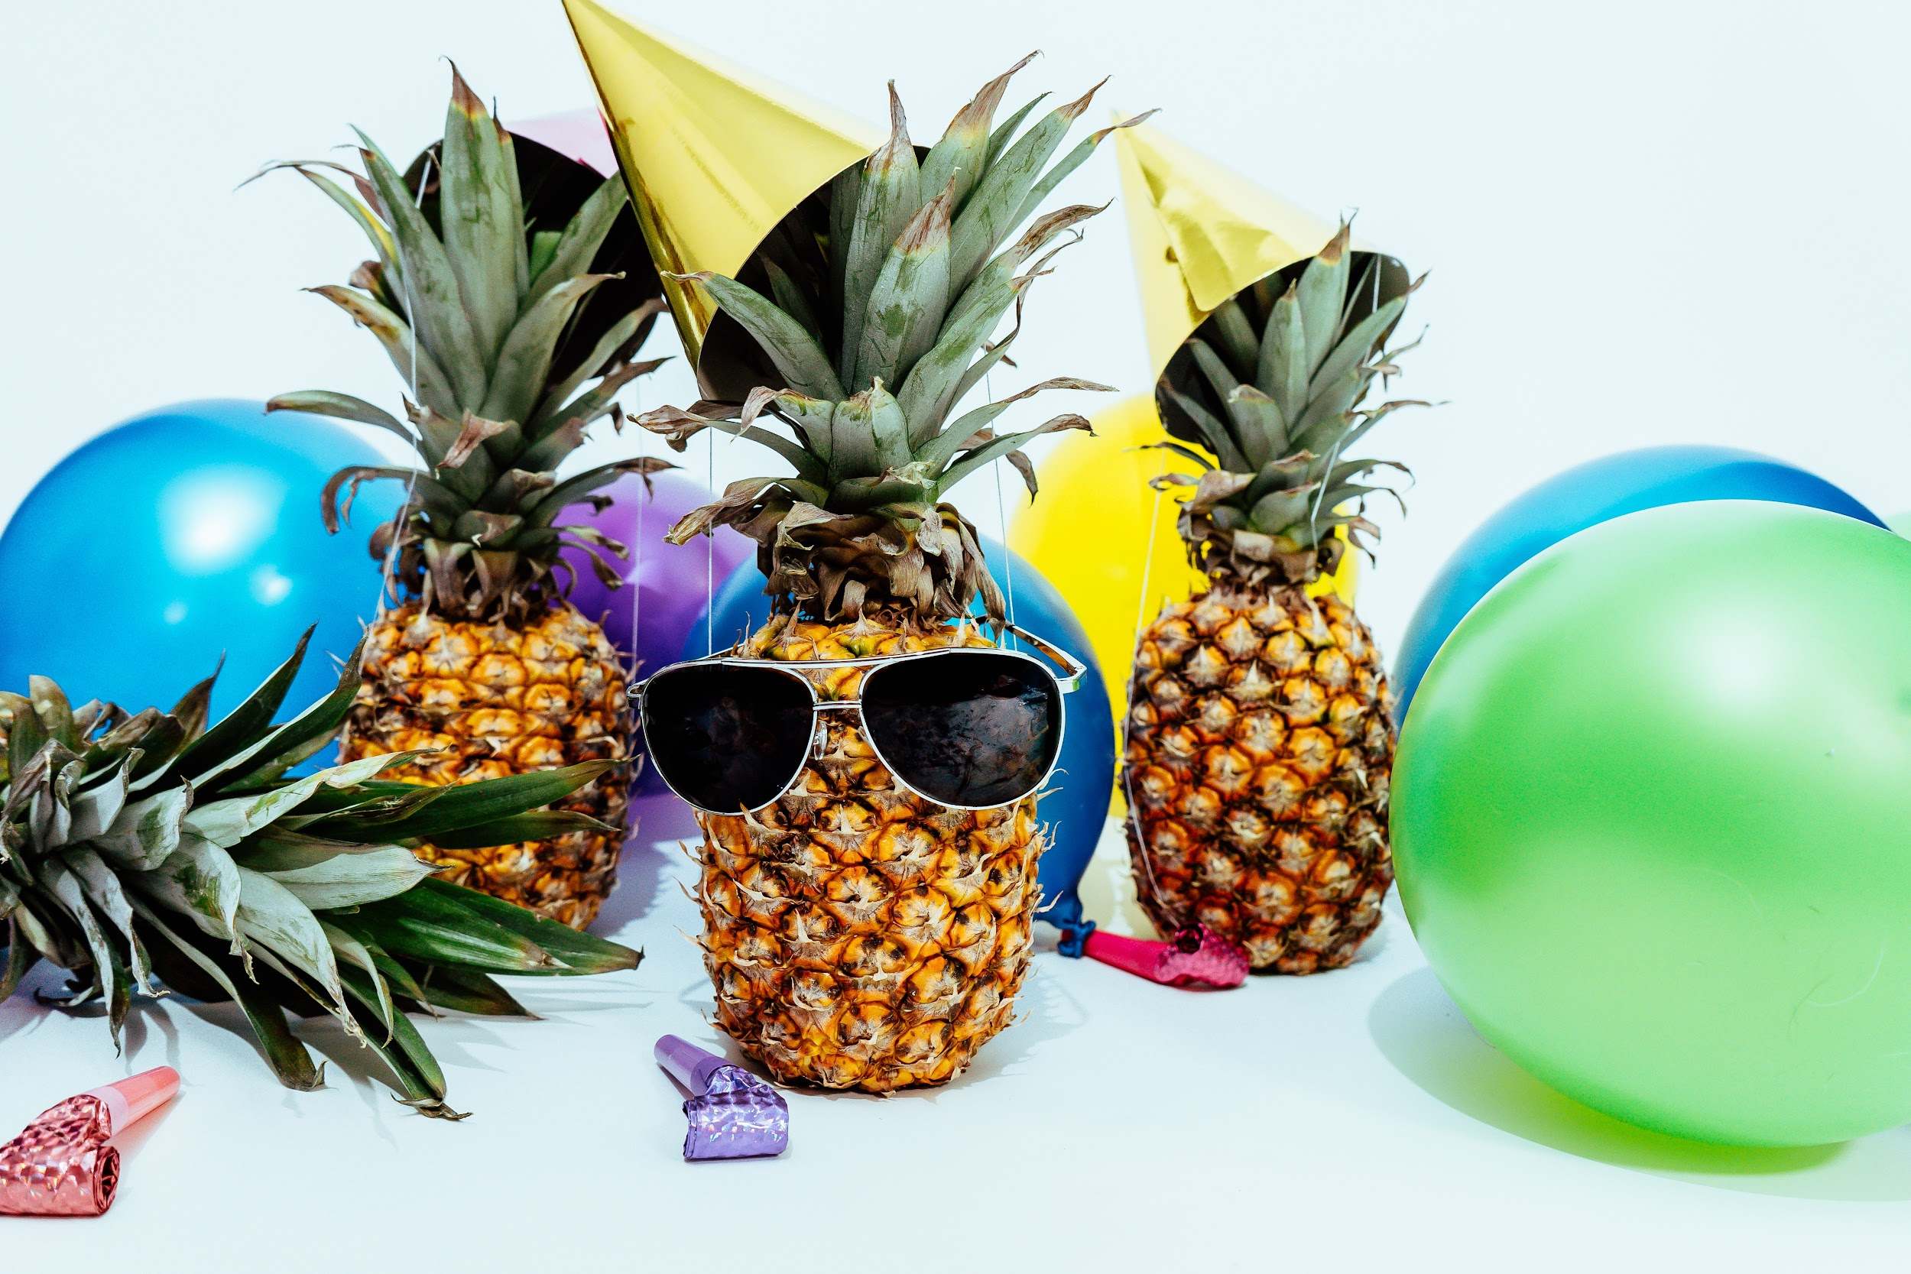

Photo by [Pineapple Supply Co.](https://unsplash.com/photos/qWlkCwBnwOE?utm_source=unsplash&utm_medium=referral&utm_content=creditCopyText) on [Unsplash](https://unsplash.com/)

This is an invitation to Open Educators, new, emerging, and veteran, to respond to the four questions below as if you are speaking directly to your learners. My ultimate goal is to openly license the resulting list so that educators can use it to orient themselves to the underlying purposes of OER-enabled pedagogy, refine their own messaging to students, and remix the content into media-rich learning objects for and with their students.

*Let’s* ***invite students to the party*** *by responding to these four questions:*

# How does creating something new, or revising / remixing an existing OER, support my learning?

* Through the process of creating something new, you engage in deeper levels of thinking, planning, reflecting
* You can build skills beyond the intended learning outcome
* You can take your learning in a direction that it meaningful to you
* The product of your work can have a larger impact than simply earning one grade in one course
* African Proverb..***Each one teach one***. I deepen my own learning when my thinking is on display and when the thinking of others is visible. There is so much more to learn than just the end product.
* Constructivists hold that people can only learn by actively manipulating learning material, not passively consuming content
* This approach allows you to be an agent of your own learning, rather than a vessel for content to be dumped into
* Connecting your intrinsic interests to coursework will increase motivation and relevance
* When you are able to freely use a resource, create a resource or remix a resource without the fear of copyright infringement, your imagination is free to soar to new heights. Collaboration, brainstorming, trying and testing become the norm.

# How might the artifacts of my learning benefit others?

* As a student, you can anticipate future students’ needs and create resources that will support then through their learning process
* Viewing student-generated examples can empower learners to think creatively about the work they produce in the course, by remixing what you created or building something new
* Multiple perspectives allow for that kaleidoscope view , others may consider another lens on the activity
* You are inspiring other students to try something new, take a risk and make something possible. You are also helping anyone in the world who could find value in your work such as video, an article, blog post, image, and more.

# Why would I make my work available publicly?

* Showcasing your work in the public domain can make the time you spend on your assignments more meaningful, valuable
* A record of your learning will be accessible by friends, family, employers - anyone who wants to see it
* By sharing your work, you can support others’ learning beyond the bounds of the course, institution, even country of origin
* As fodder for continuous quality improvement, to keep deeper conversations alive.
* When you put so much time, effort and energy into creating something, wouldn’t you want more people to see it beyond just you and your teacher? Wouldn’t you want it to be much bigger and more impactful?

# Why would I openly license my work?

* When work is openly licensed, you give others explicit permissions to do certain things with it, such as the 5R permissions (retain, reuse, revise, remix, redistribute). Examples include:
  + Downloading a copy for personal use (rather than relying on a website or Learning Management System for access, for example)
  + Incorporating your work in a class presentation, video, or website
  + Translating into different languages
  + Combine your work with something else to create something new
  + Share this work with others
* To put values in action, to reduce costs for learners, to democratize learning, to embrace multiple ways of knowing.
* If you’ve ever benefited from using Open resources, you would see how easy it is to be assured that what you are using is not copyrighted. You can pass this on and help someone else who could find value in your work. A great way to share knowledge - isn’t that what education is all about?