Collaborative Note Document - TESS2019

Please consider a common format at the top of your notes:

Session Title:

Your name:

Contact Info if you want to connect with others:

# **Voice Ed Radio interviews: LINK**

Check out interviews from [#TESS2019](https://twitter.com/hashtag/TESS2019?src=hashtag_click) here [@candersHamilton](https://twitter.com/candersHamilton) [@NurseKillam](https://twitter.com/NurseKillam) [@data_professor](https://twitter.com/data_professor) [@jennihayman](https://twitter.com/jennihayman) [@elearn4u](https://twitter.com/elearn4u) [@triciadonovan](https://twitter.com/triciadonovan) [@IrenequStewart](https://twitter.com/IrenequStewart) [@xinli_w](https://twitter.com/xinli_w) [@JamesMSkidmore](https://twitter.com/JamesMSkidmore) [@hj_dewaard](https://twitter.com/hj_dewaard) [@kylemackie](https://twitter.com/kylemackie) [@giuliaforsythe](https://twitter.com/giuliaforsythe) [@DonnaLanclos](https://twitter.com/DonnaLanclos) [@bonstewart](https://twitter.com/bonstewart) [@donpresant](https://twitter.com/donpresant) [@greg_rodrigo](https://twitter.com/greg_rodrigo) [@dendroglyph](https://twitter.com/dendroglyph) [@lpatter10](https://twitter.com/lpatter10) [https://voiced.ca/project/tess2019/](https://t.co/DWdssxoDNk?amp=1)

# Opening Plenary with Donna Lanclos [@DonnaLanclos](https://twitter.com/DonnaLanclos)

The Anthropologist in the Machine

Collaborators: Jenni Hayman (others?) (Helen DeWaard)

Contact Info if you want to connect with others: [jenni.hayman@cambriancollege.ca](mailto:jenni.hayman@cambriancollege.ca)

Notes:

Benjamin Doxtdator and Lawrie Phipps are Donna’s colleagues and supporters for this preso.

<https://biz.bo/018763> for questions related to the preso.

“Academia is my village”

Anthropology approach is “deep hanging out”

Sometimes when we talk about innovation, we should be talking about creativity. Do not weaponize innovation in education.

UK Publication - Realising the potential of technology in education, UK Department for Education. Report emphasizes markets over education (as a social justice issue).

JISC research. Listening to Teachers (Lanclos and Phipps, 2019)

Their research is kind of the antithesis of the UK report, they started off asking about teaching

(slides will be shared by Donna, likely)

Phipps & Lanclos (2018) - this seems important to read

The importance of peoples’ personal learning networks is critical

In an education context, large cities can suck all of the oxygen out of peripheral regions (sound familiar Ontario?)

Digital connection can provide a chance for marginalized institutions to increase funding and power, to make an impact

Examples and conversation about anthropology and colonialism, The Nuer by E.E. Evans-Pritchard

Franz Boas - The Color of Seawater, known as the father of American Anthropology, the disappearing narrative and salvage anthropology took hold at the turn of the century and this empowered “Replacement” phenomenon.

Ruth Benedict - Japanese study, work was complicit in the military mission during WWII

Margaret Mead - also problems with her work, but shifted away from control to understanding

Make the unfamiliar, familiar and the reverse

She brought practices of other people to North American culture and attention of people in a transformative way

Education, schools, and libraries are not neutral

Schools have a deadly and damaging reputation among Indigenous people globally

We’re often talked to (at) about the future of education, often about markets, concerned about the future as a concern about the deficit in technology, then we are sold products to remediate the problem

Terra nullius - the land is empty and therefore available for you, this approach to digital takes away the ability to recognize and encourage good practice

Refusal - choices about what you do and do not engage with

Everyone has a reason for doing the things that they do

Susan Harden [sharden@uncc.edu](mailto:sharden@uncc.edu) active learning classroom kit in a bag example

What is the digital equivalent of Susan’s physical kit?

All of the digital systems we’re handed are grounded in outmode cultural systems

“For whom, and at whose expense?”

Dispense with the idea that the centre contains the most important practices

Listen to the people in our communities we don’t have to worry so much about centre and periphery

Settler Futurity - an assimilation and erasure model

Nnedi Okorafor Binti - important writer

I am insisting that my people are in the future, she is writing the future

Initiative for Indigenous Futures (website) refusal of Settler Futurity

What can people that have been traditionally centred learn when we decentre and learn from others?

How do we learn from people without insisting that they teach us?

Digital gives us access to people, we don’t need corporations.

Who decides what constitutes impact?

We do not have to choose basics over creativity, it is not a zero sum game.

How do you share the power to experiment?

Advocate for centring historically marginalized voices

We need to avoid being cogs in our respective machines

Build the Future, it has to be co-created, don’t wait around for someone to hand you a vision of the future

Advice to librarians, get out of the library

Kate Fox ”Watching the English” is more of a travelogue than anthropology

#### Opening Plenary links and Resources

1. Realising the Potential of Technology in Education: <https://assets.publishing.service.gov.uk/government/uploads/system/uploads/attachment_data/file/791931/DfE-Education_Technology_Strategy.pdf>
2. Listening to Teachers: A qualitative exploration of teaching practices in higher and further education, and the implications for digital by Donna Lanclos & Laurie Phipps <https://www.jisc.ac.uk/reports/listening-to-teachers>
3. National Residential School Registry <https://memorial.nctr.ca/>
4. Binti series - Nnedi Okorafor <http://nnedi.com/books/binti.html>
5. Initiative for Indigenous Futures <http://indigenousfutures.net/>

# Session A1: Preparing for Success Online

Elspeth McCulloch

[elspeth.mcculloch@carleton.ca](mailto:elspeth.mcculloch@carleton.ca)

@elspethmcculloc

Presentation Slides include link and QR code to access full learning modules  
<http://bit.ly/37hn05t>

Preparing for Success Online (Carlton)

Modules developed alongside the student success centre to help prepare students for success online.

View their modules at [bit.ly/2CPuMpb](http://bit.ly/2CPuMpb)

# Session A5: Becoming Badge Savvy: Integration of Digital Badges into Faculty Professional Development

Your name: Mel Young

Contact Info if you want to connect with others: [mel.young@cambriancollege.ca](mailto:mel.young@cambriancollege.ca)

@melyoung00

* Micro-credential working group created at presenter’s institution
* Seneca definition: micro-credential is a recognition of achievement for a small set of competencies / badge: an online, shareable representation of a micro-credential
* Apply to TLC for badge, Claim, Display, Share
* Badges can be shared in PDF form now or you can still use a backpack
* 459 badges issued to 323 participants (Oct 1 2018 - Nov 2019)
* Communicate Value of Micro-credential: need the badge to be recognized (by viewer, earner and issuer)
* Alignment of Micro-credential to standards of practice for faculty (Seneca)

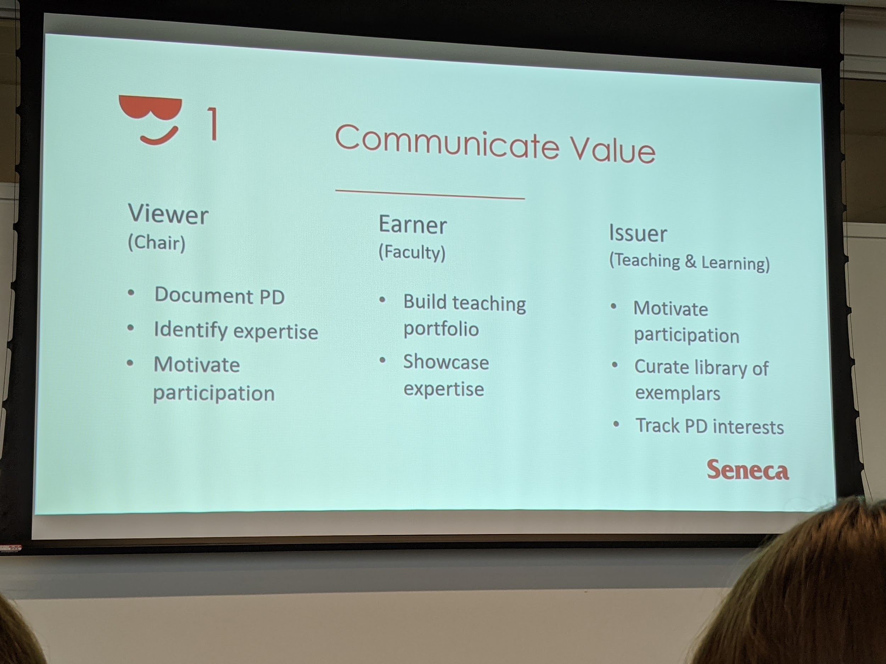

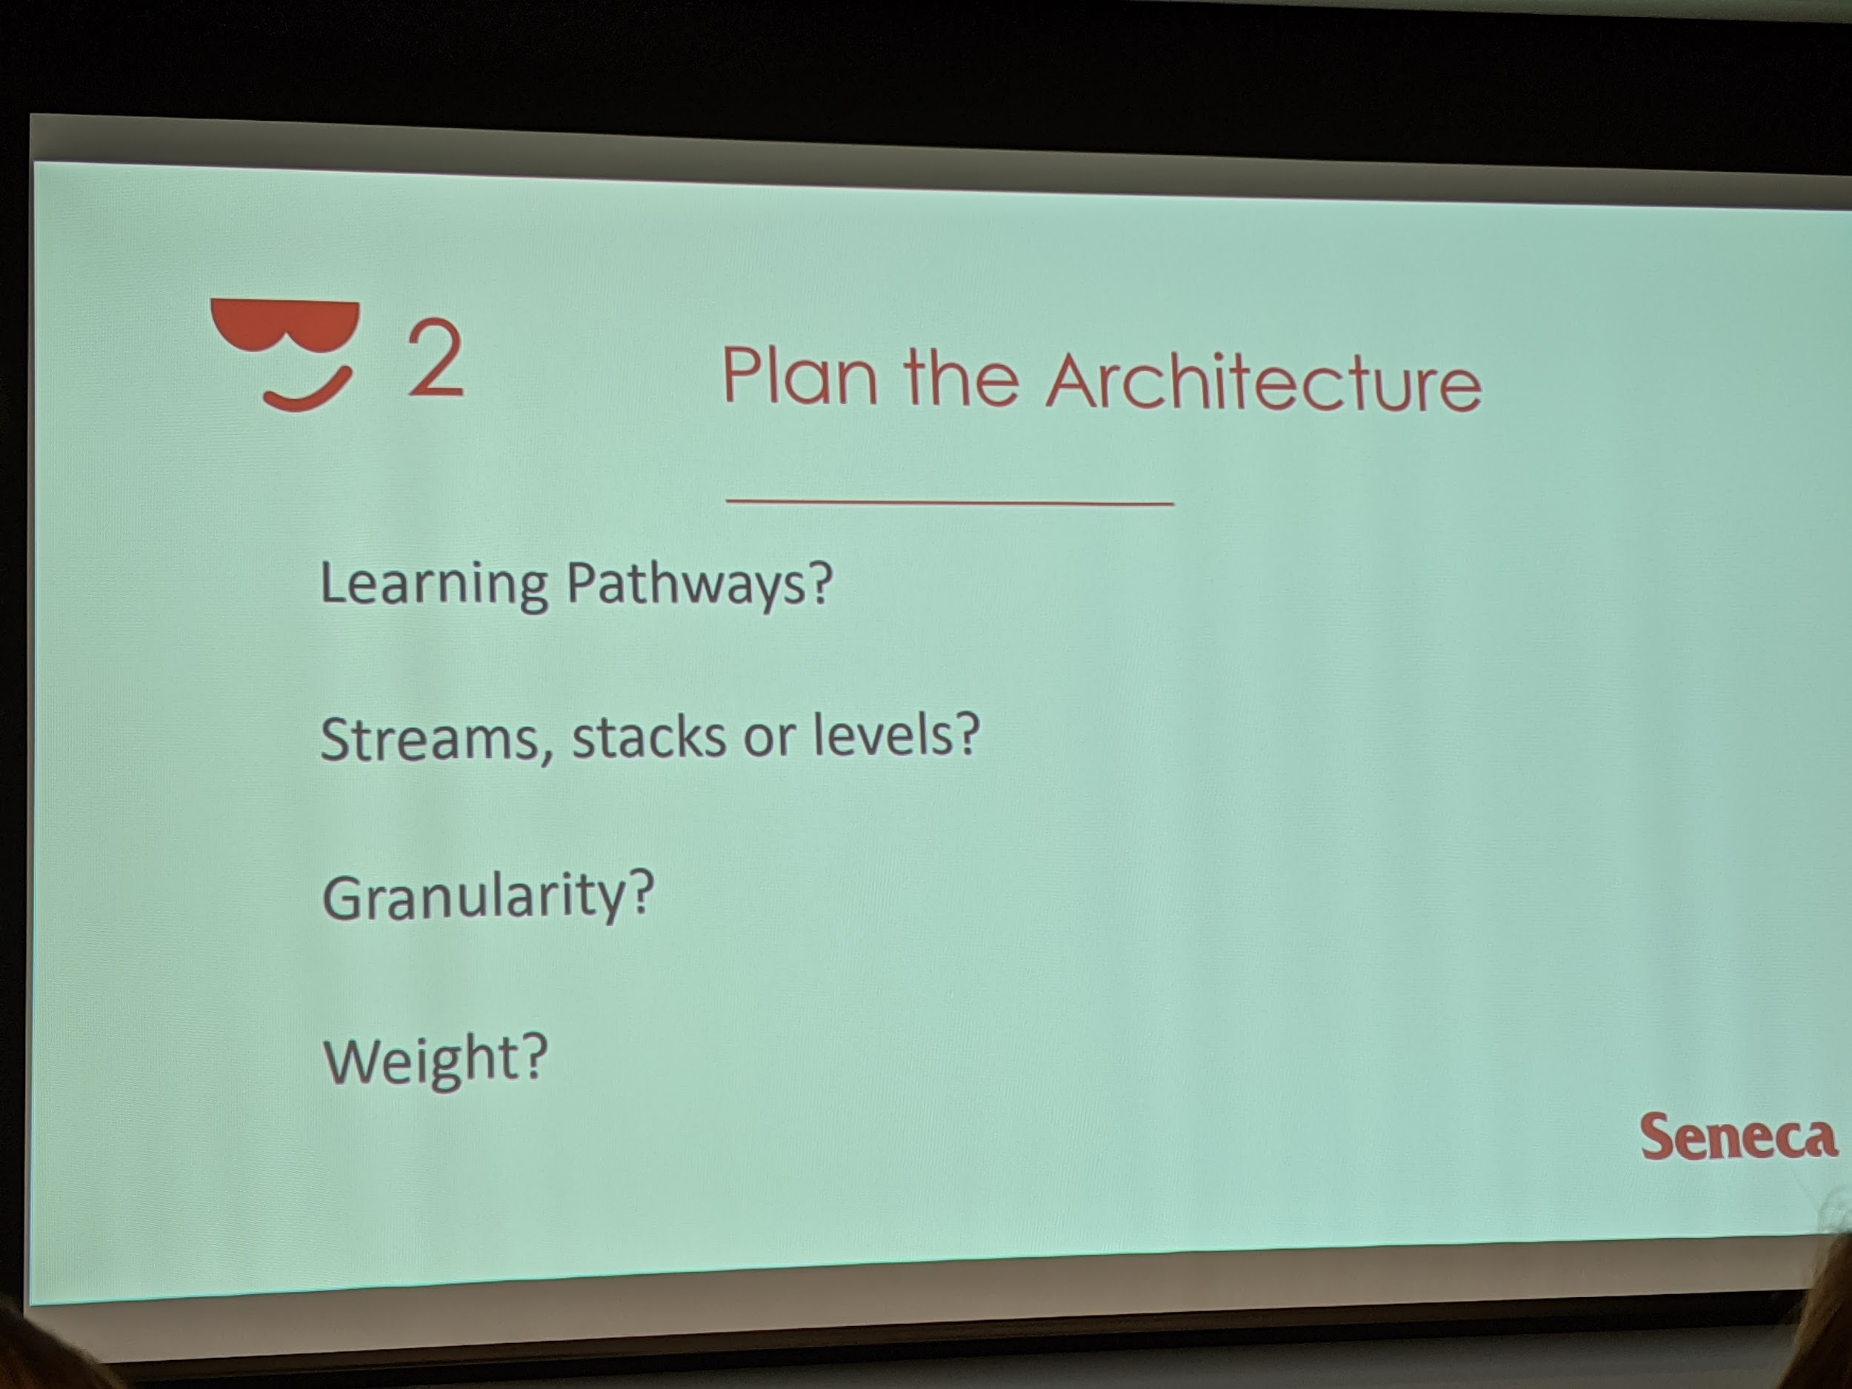

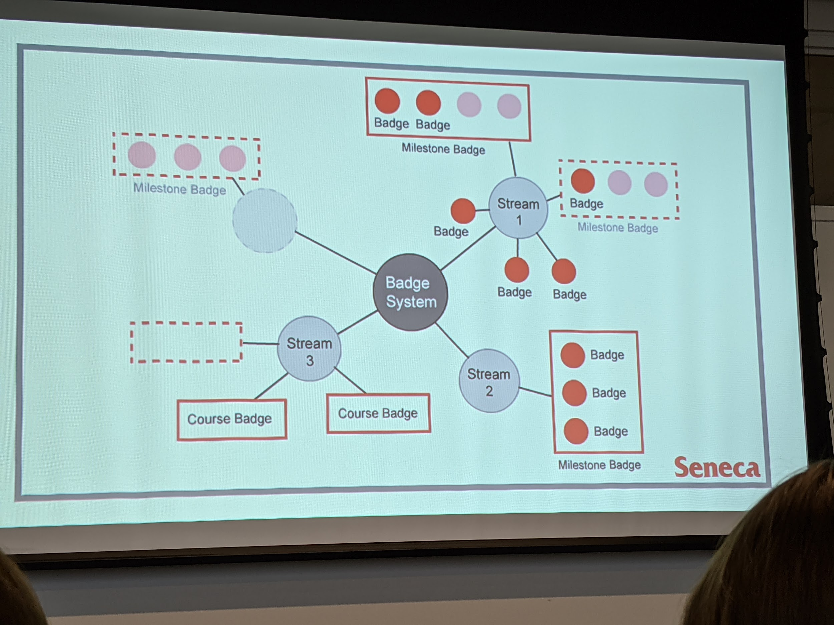

* Planning badges by using streams
* Seneca's Micro-credentials are based on competencies and evidence, not outcomes and objectives; important to think about assessment method beyond tests

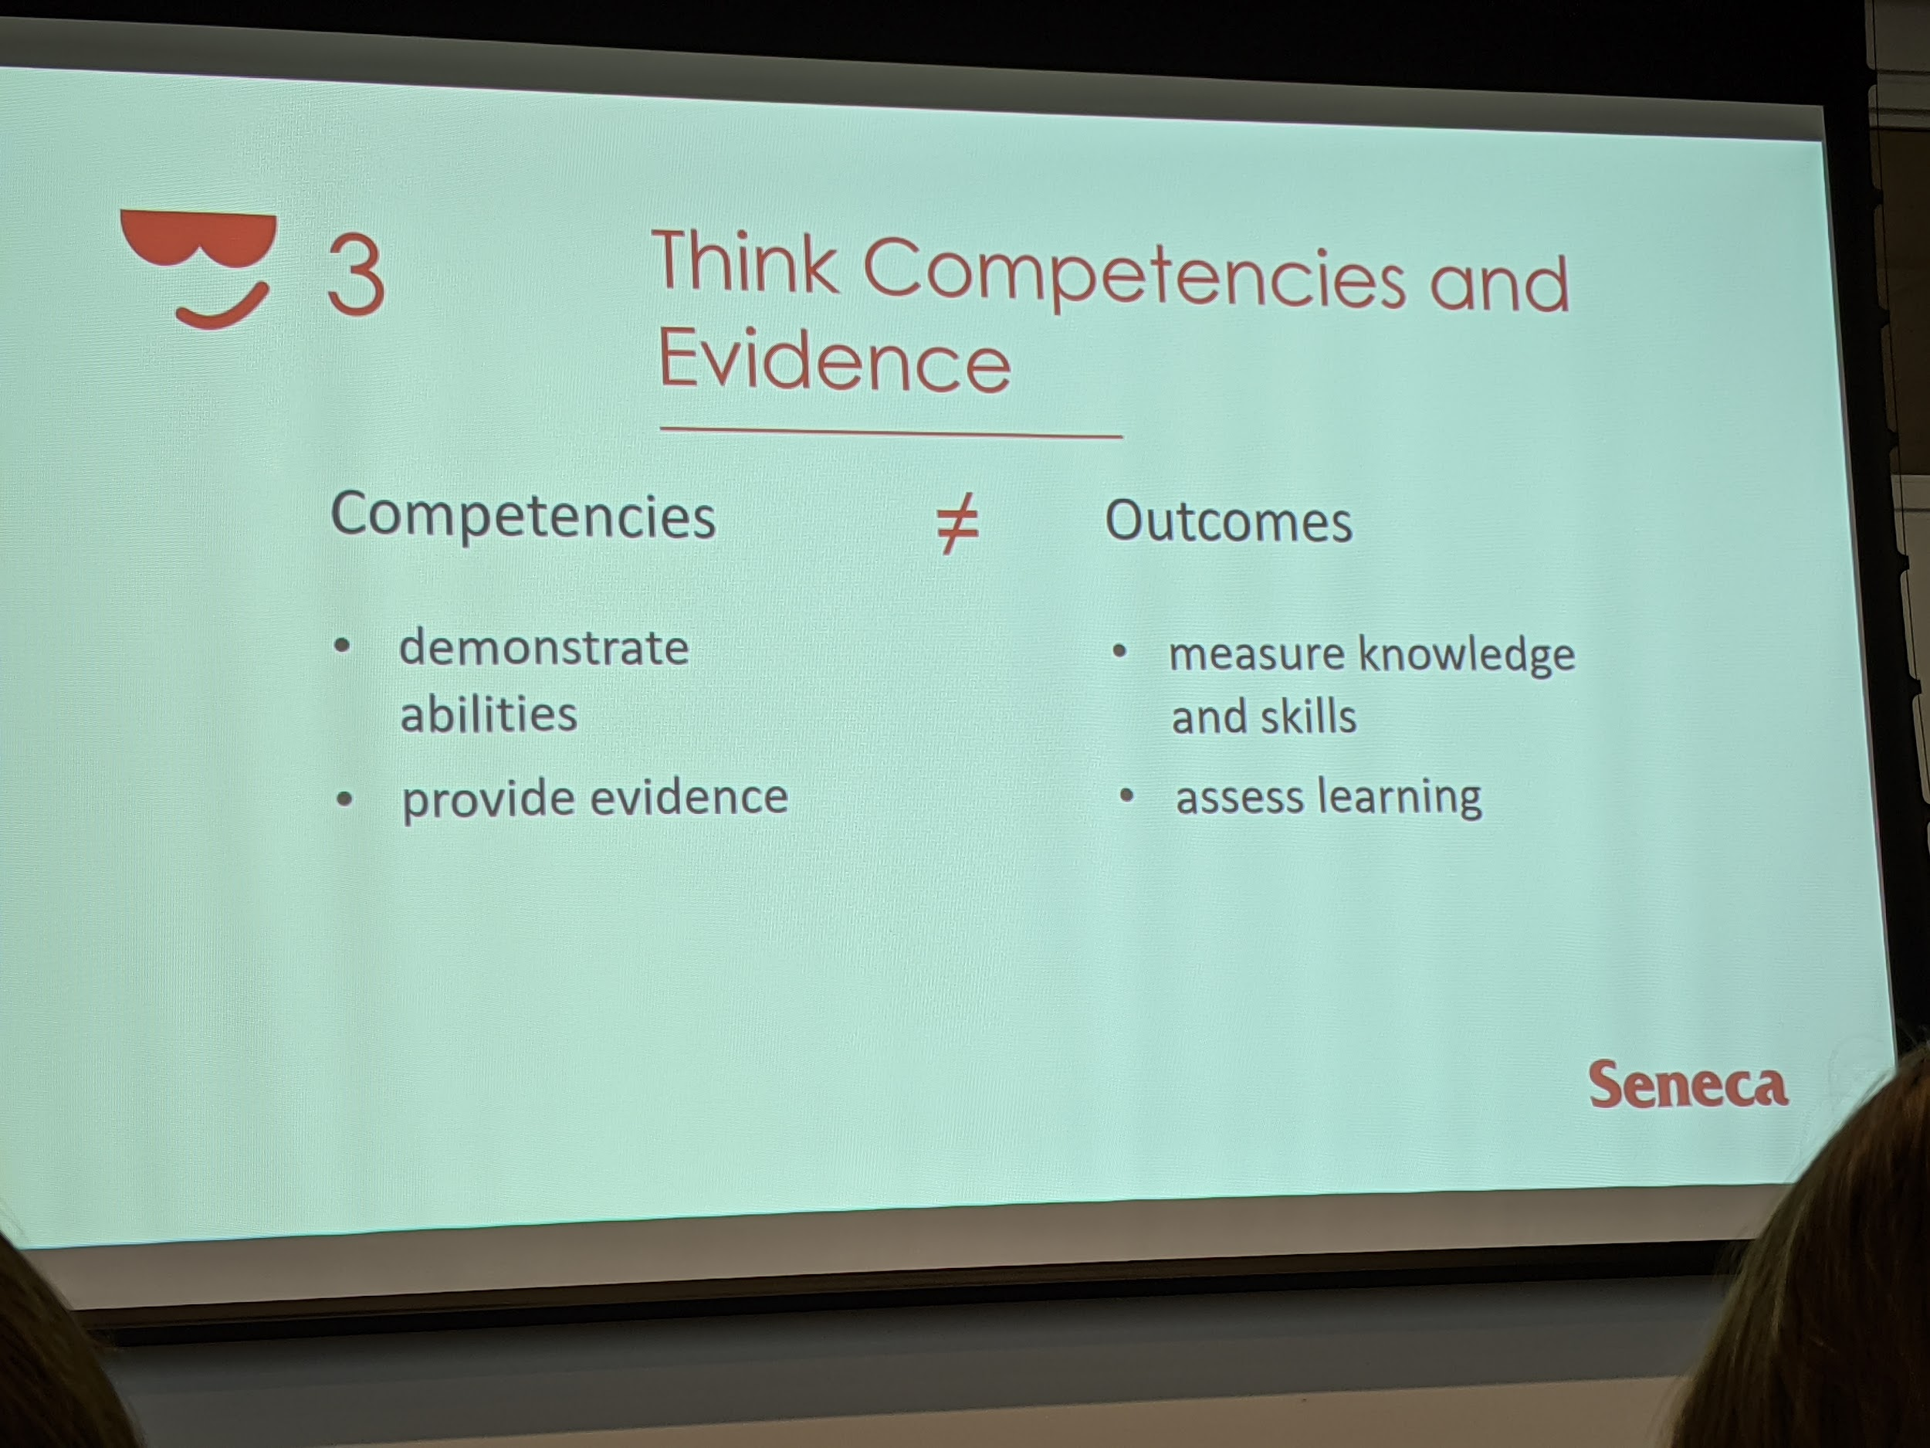

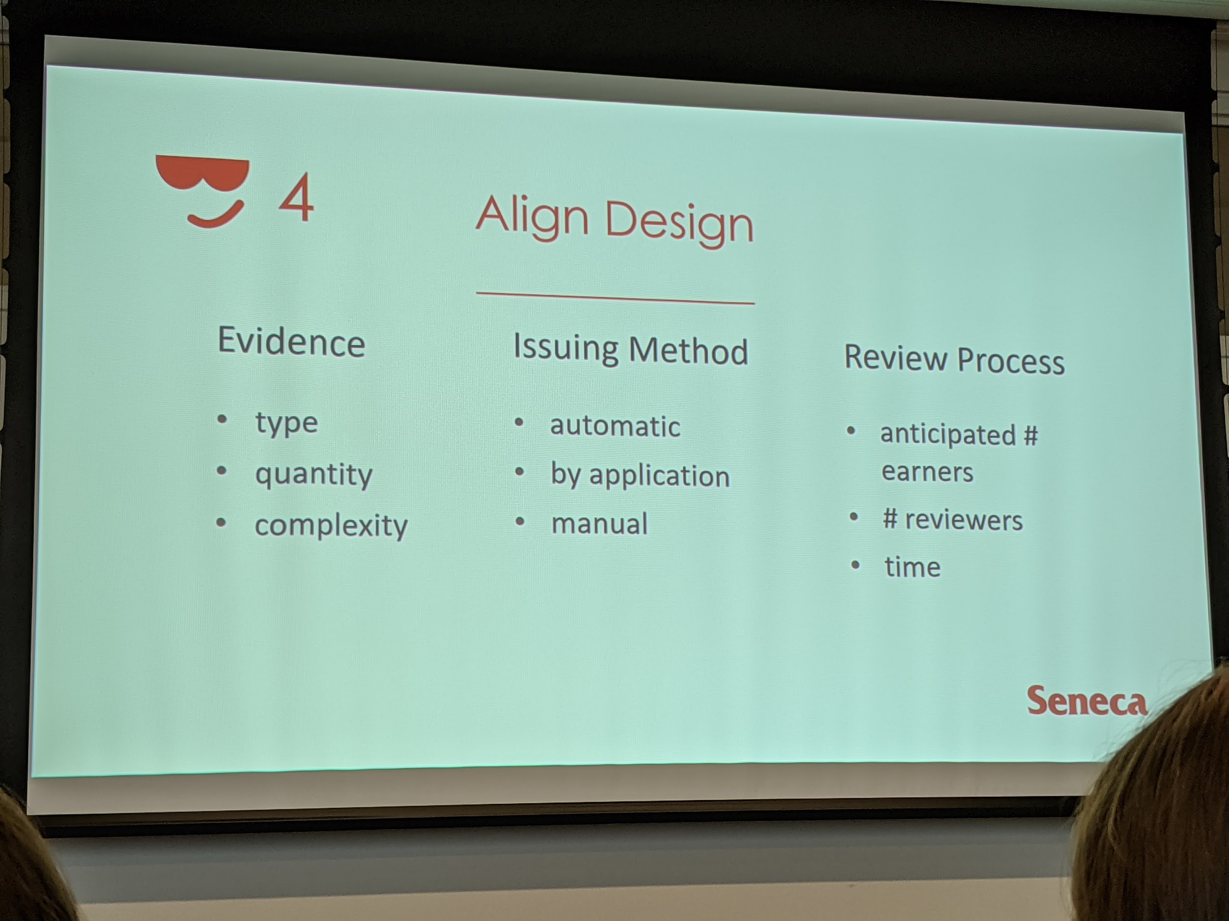

# Session A6. Micro-credentials: Building Competence by Theresa Steger from St. Lawrence College

Mel Young

* Modules are becoming more common; the idea of a "course" may be outdated
* Reiterated micro-credential assessment based on assessment
* Digital badges are a great way to issue micro-credential
* Students prefer a credential to show attainment of competencies to their employers based on workplace competencies
* Challenge: a learner could pass a course without achieving the badge because students had to pass the application based assessment ties to the badge, not contingent on passing the course
* Transcripts don't show the full story of their academic experience; just a list of courses

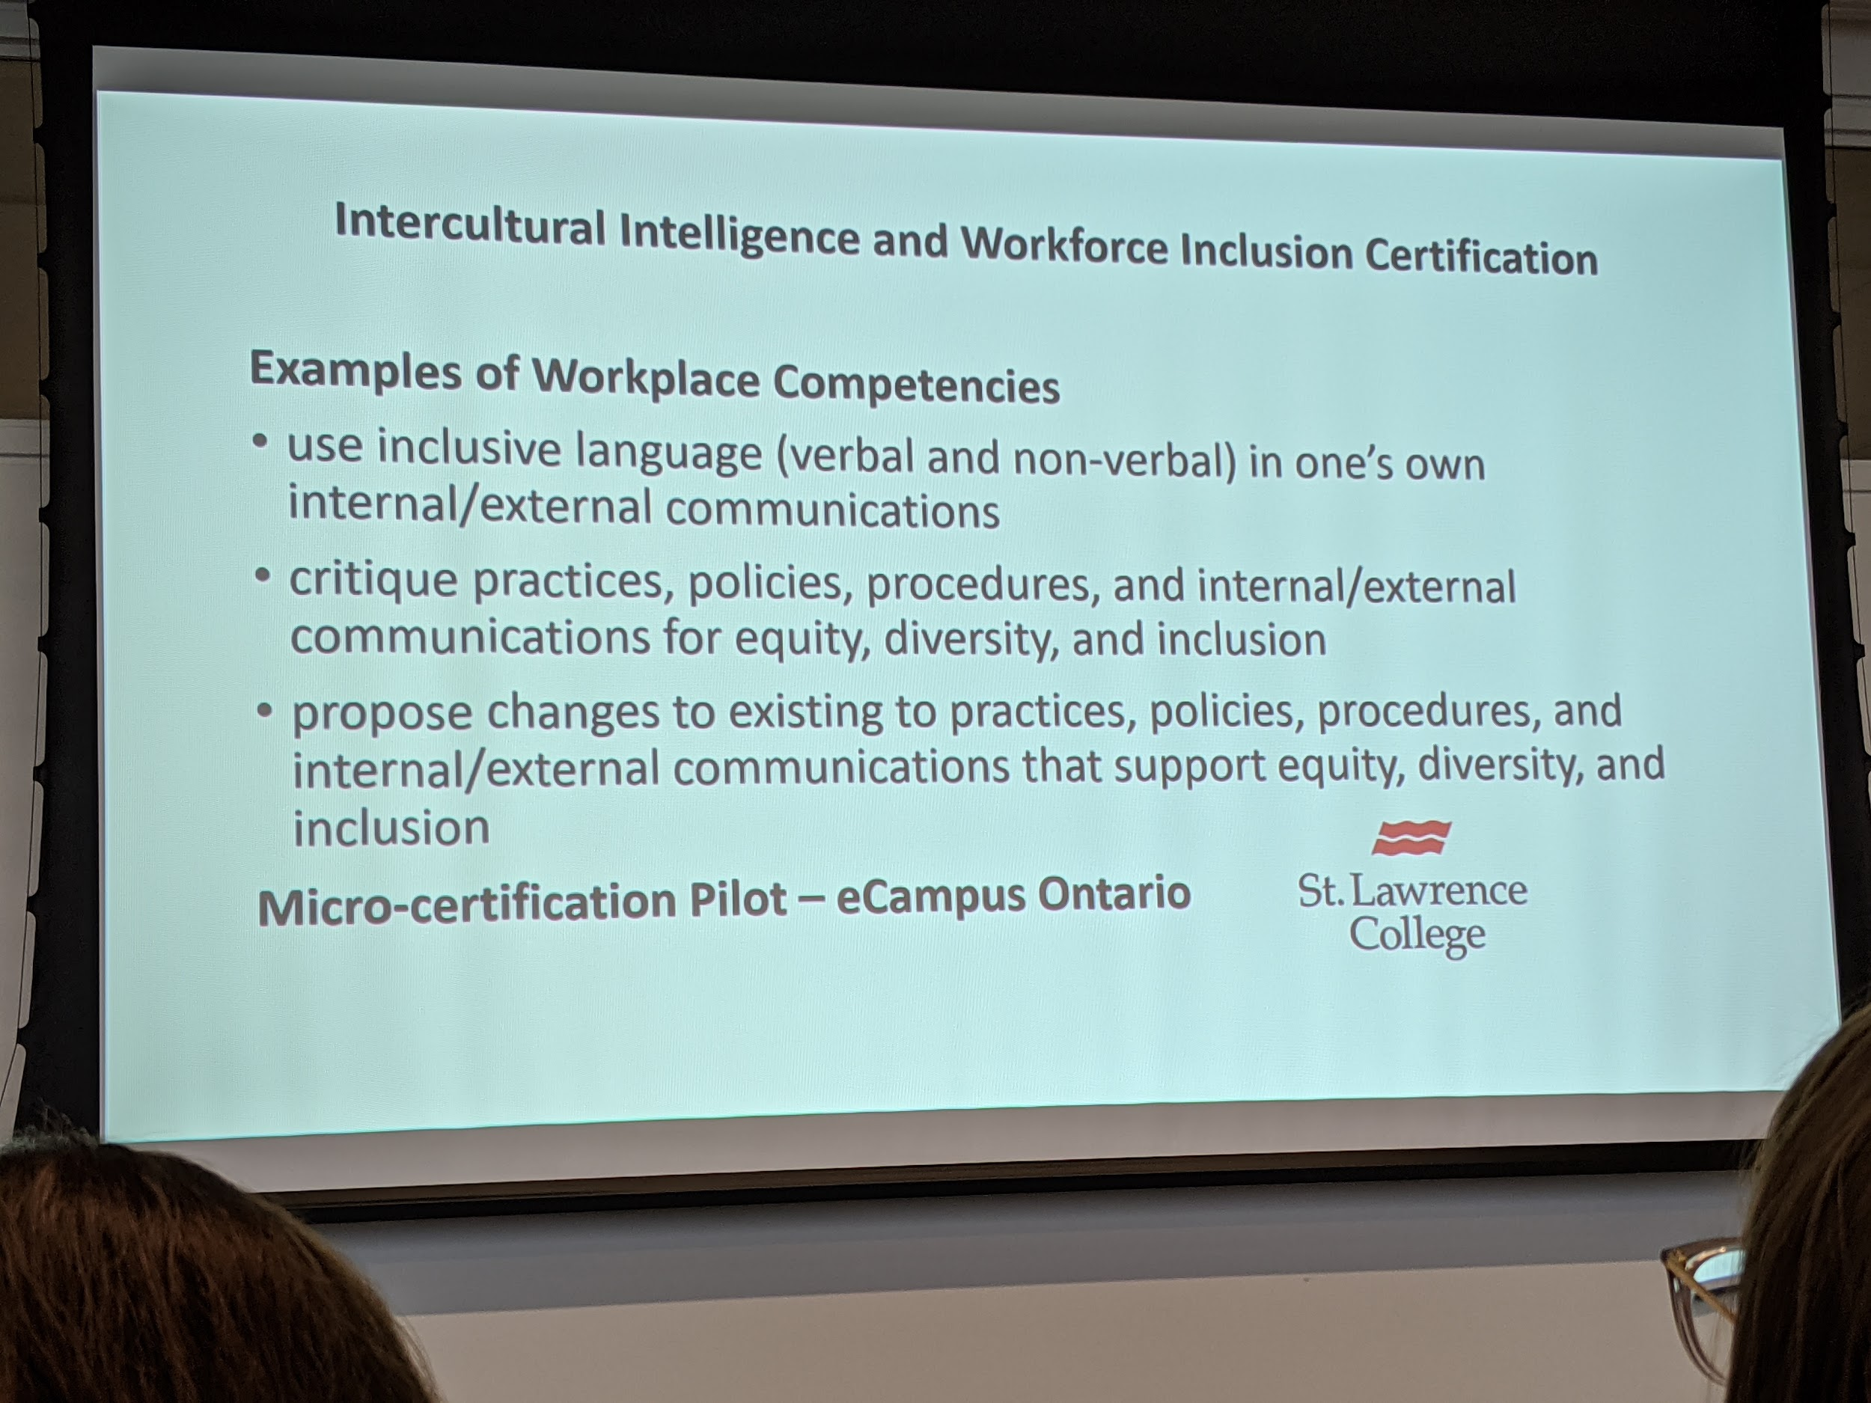

Resources

Fong, J., Janzow, P., Peck, K. (2016) Demographic Shifts in Educational Demand and the Rise of Alternative Credentials

# Session A7. Thinking Like A Historian, Taking a Competency-Based Education Approach

Natalie Green, Lena Kushnir

UGuelph

By Mel Young

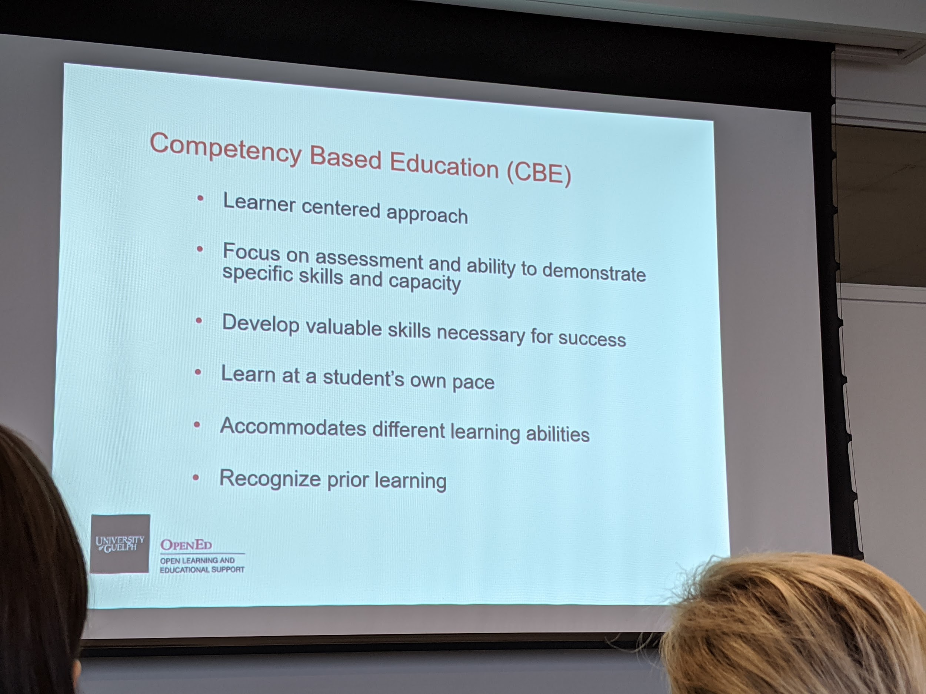

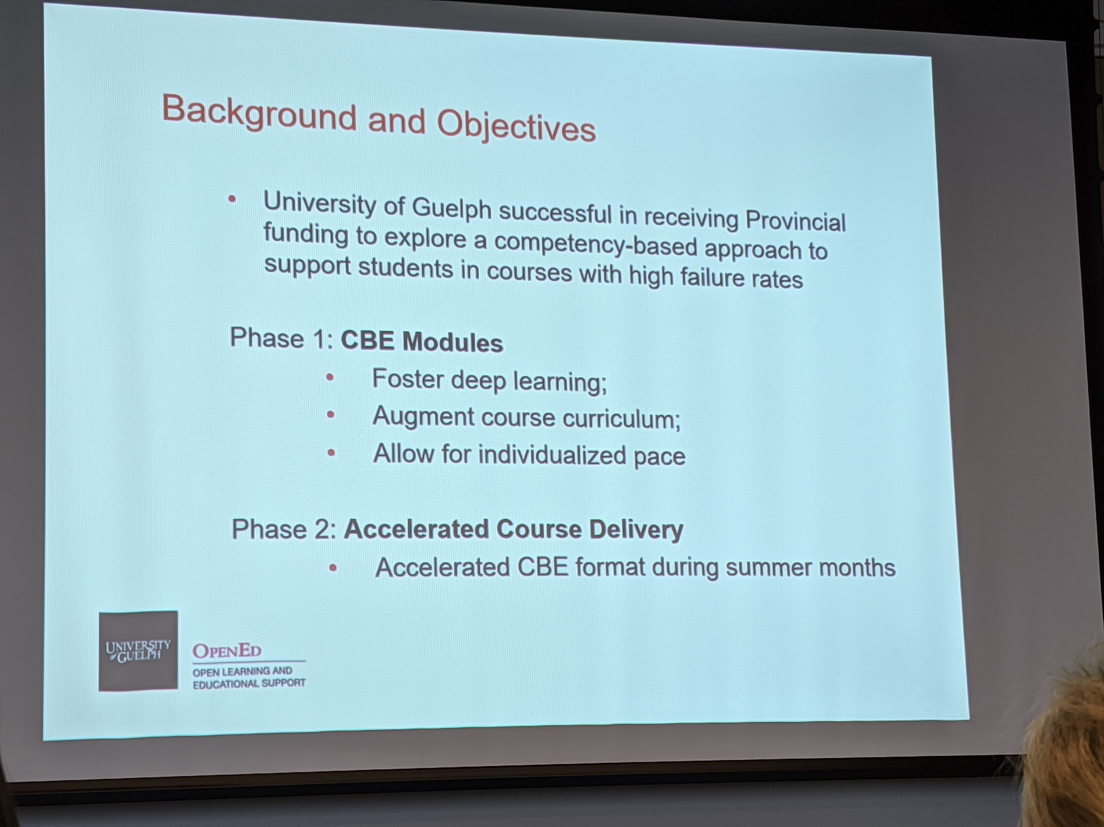

* Students get a digital badge for completing the ungraded module (ex used: finding and analyzing primary sources module for history courses)

# Session A11: Behind the Scenes: Joint Consultation and Collaboration on Core Success Skills at Two Ontario Institutions

Sarah Stokes, Fiona McArthur, Andrew Hogue (Ontario Tech)

Alexis Morris, Carolyn Hoessler (OCAD U)

Contact: [badges@ontariotechu.ca](mailto:badges@ontariotechu.ca) or [sarah.stokes@ontariotechu.ca](mailto:sarah.stokes@ontariotechu.ca)

Slides: <https://docs.google.com/presentation/d/1vEPOJfDYga1xfxfW8aNK_gRCurg2ipIbbg5t413m3VM/edit?usp=sharing>

# Session A13: Where to start to explore virtual reality (VR) for teaching and learning and how to create effective VR Learning experiences with 360-panorama virtual tours

Presenters names: Gillian Dabrowski & Lynn Long

Used with Ecology course at UWaterloo; VR 360 video embedded into LMS with quiz questions; accessible version of real life field trip experience that is one of the four required field trips for the course; used camera that was available through the ecology department; new skill learned was how to stitch images together;

References: Parong, J., & Mayer,

See some of the [Slides](https://docs.google.com/document/d/14nxJZ9DjS-pbuP-x44daMRzxHOMTSq-2Ncrj-VuAE2U/edit?usp=sharing)

# Session A14: Integration of VR in a training techniques course

Presenters: Tania Killian & Bev Beattie; Seneca College

* VR in HE - advantages and disadvantages; can’t have students move into dangerous situations; training in VR then move into real life situations; “no one dies here”
* Occulus Quest sets now coming down in price $780 now
* Workplace safety and prevention program; course learning outcomes; fit with VR - not just putting VR in anywhere, make sure it fits to what you are trying to do e.g. safety of hydro line workers
* Research to support this - Norris, Spicer, & Byrd, 2019; Zhao & Lucas, 2015
  + Integrates experiential learning (Kolb)
  + Replicates workplace safety scenarios
  + Enhances learner engagement - student testimonials, faculty observation
* Course package can include the headset
* 360 Insta-pro camera ($6000) - do walk through video and stitching on it;
* Grant gave $$ for camera and headsets
* An opportunity for research here - simulations as next step;

See some of the [slides](https://docs.google.com/document/d/1HXLRj1oXYqM1kYtoCu_yA12TbjAWFjG1ogAL8YDwOk4/edit?usp=sharing)

# Session A15: Exploring the use of a Google expedition kit to create immersive learning experiences in earth and environmental science

Presented by Jason Thompson and Lynn Long at UWaterloo

From the Dean’s undergraduate teaching initiative - Faculty of Science

* Using emerging technologies to enhance field, experiential and active based learning in earth and environmental sciences
* Getting to the Grand Canyon

Anatomy of a Google Expedition Kit (GEK) $10,000 - 20 VR headsets

Advantages and disadvantages

Cost effectiveness; self contained; mobile; tested in K-12; Free app; over 800 tours available; can create your own tours (Poly) <https://poly.google.com/>

* Guided feature and self guided tours;

AR/VR community of practice - coordinated through CTE and CEL at UWaterloo

* Lynn is working with this community of practice; monthly sessions
  + January EON AVR - part of eCampus pilot

This does not replace current requirements for doing field work as course outcomes; administrators need to beware of tagging this as a ‘cost cutting or cost effectiveness’ way of course delivery, or taking away the field work.

Interest in skilled trades; - situational context vs

Alternative research Bruce Wainman at McMaster - no discernible difference in using VR; but may not be situational or social VR scenarios

See some of [the slides](https://drive.google.com/open?id=1zsZDDWAre8BFdvLqJxfgdawSbCFRItRydcvUy_XPKxk)

# Lunchtime talk with Tricia Donovan related to the National Online Survey:

<https://onlinelearningsurveycanada.ca>/

Link to the survey, Ontario specific report coming very soon!

Some [slides](https://docs.google.com/document/d/1wq0mD76qemB-7PdevXoLm_lrlzOpBGCUx-R3p5qXeok/edit?usp=sharing) with highlights for Ontario

# Session: B16 Smartphone Accommodation Resource Toolbox (SMART)

Presenters: Iris Epstein and Justeena Zaki-Azat

Link to the website:

<http://smart-toolbox.eecs.yorku.ca/>

# Session: B17 The art of serious game design

Presenters: Alissa Bigelow and Amy Goruk

Link to training resource:

<https://de.ryerson.ca/games/research/>

# Session: B20 The Legend of Extend: An Empowered Adventure

Presenters: Terry Greene and Maureen Glynn

-video production -- the origin story in ‘Hyred’ with

Using a SPLOT to spin learning!

* Fill out the form if you are OK with putting your bit.ly/ExtendLegend
* Photoshop template - Terry has this
* Join the universe

# Session B21: Creating Value for open educational practice

Presenters: Wendy Freeman, Michelle Schwartz

4 values for open pedagogy - Sinkinson, C. (2018). The values of open pedagogy. Educatuse Review. Retrieved from <https://er.educause.edu/blogs/2018/11/the-values-of-open-pedagogy>

- access and equity, community and connection, agency and ownership, opportunity and risk

* Interviewed 8 faculty members, projects funded by grants; from Ryerson teaching community

1. Agency and ownership - creating the right content to match the course; getting students involved; teach students that they have their own agency and ownership within themselves; need to create a cohesive curriculum; creating good quality content
2. Community and connection - giving more feedback to students, helping middle/good students achieve potential; more time for individual feedback; using and sharing resources all over;
3. Access and equity - free online videos; open resources are philosophically aligned with courses that are about access, can engage students with issues of access; replace a big, heavy textbook; creating free resources;
4. Opportunity and risk - new and exciting things like games can be used to facilitate learning; exploring new ways of publishing and using technology; found a place to do something cool; creating the right resources despite difficulties with open libraries and licensing; marketing and product view e.g. open encyclopedia;

* talk to your librarian to see which CC license is the best fit for your project

- everyone had their own path to come into open and a different path as they went through their projects

- research ethics needs to have these participants approve of the release - the actual release will happen in early spring; but are part of the open library resources

# Session B22: Creating and adapting OER with students for students

Presenters: Nada Savicevic, Jennifer Lapum, Oona St-Amant, Arina Bogdan (created the images in the text); Michelle Hughes

-students co-created the text (nursing) - attribution statements at bottom of the pages

-pressbooks - last chapter includes academic integrity

-successful because of partnerships with experts including students - librarians, writers, student leaders, student faculty advisory committee, the student experience

- Arina - students have voice in textbook; having a say in the activities and characters in the book

- Instructional design - development process (learning outcomes, content; student and educator feedback)

- universal design and accessibility - a variety of methods to present content; best practices for accessible online content

Multimedia - visuals (drawings); podcasts, videos, interactive learning objects such as tables and figures, interactive questions, pressbooks and H5P

* Student engagements and UDL accessibility

Think about ‘uptake’ early - when creating the OER - what programs can use it, place in specific curriculum; Sharing OER - champions of the OER, stakeholders such as student and faculty advisory committees

# Session B23: Building the open page: OER as textbook in a blended service learning class

Presenters: Bonnie Stewart and Mark Lubrick

Slides: <https://docs.google.com/presentation/d/1tPU_cRtNaR_LfuVX_XiWQN4TatZ1qadybg3h4G87KRQ/edit#slide=id.p>

The Open Page - live link from Faculty of Ed web page <http://www.uwindsor.ca/education/openpage>

The Open Page = #UWinToolParade - student developed short videos & podcasts

Professional development for K-12; parent engagement sessions; service learning

* Teacher to teacher open overview - is this tool worth my time to learn

Focused on data and differentiation - equality and equity

Will have 12-15 videos; half are student created; 10-12 podcasts; lesson plans

* Participatory textbook; legitimacy with teachers in classrooms
* Students have done all the work to script, design, produce the videos
* Video about Canva or Picktochart - <https://youtu.be/eAMiAxa2770>

Mark Lubrick - team needed an asynchronous communication - uses Slack to share files back and forth; mixing in video types with intro using the light board video; write out some of the text

* Practiced in ‘sounding like a human’ and highlighting the text that required emphasis
* The student team now does the editing themselves
* Podcasts are next stage - using Audacity for editing
* Teacher to teacher open overview

# Session B29-38 Ignite presentations: Exploring excellence in Online Learning

1. Gisele Richard
2. Carrie GAlsworthy
3. Rob Parker
4. Sally Wilson
5. Olga Perkovic
6. Sarah Stokes (sarah.stokes@ontariotechu.ca): <https://docs.google.com/presentation/d/1fzeDhd1EoztTlepMFiL9S_c_wKmSGjFdO18VvE1zUZU/edit?usp=sharing>
7. Bill Ju
8. Tricia Bonner - <https://docs.google.com/presentation/d/12VoiD7EbFcsl2TSY3BQ_54dDywccXQHQZ-ffndWcvFI/edit#slide=id.g78f95a688b_0_0>
9. Xinli Wang - [Out of the Shadows: Precarity and OER](https://drive.google.com/file/d/14yyKUQ3uCuxdnVrif-DH6k8PbM-s_uUe/view)
10. Krista McCracken
11. Marnie Seal
12. Celina Da Silva

# Session C39: Extend Your Teaching SuperPowers with Video Tools

Kim Carter (Conestoga)

Melinda Haw (Conestoga)

Lisa Koster (Conestoga)

Jelena Loncar-Vines (Conestoga)

Marie Rutherford (Georgian)

* Stories of impact of video tools on learning from the student perspective
* “Video Tools & Uses” spreadsheet for session [bit.ly/tess19](http://bit.ly/tess19) - additions welcome!
* Video as a means of following up on items unaddressed or “left on the table” in classroom
* Students enjoy using the same tools in their own presentations that have been modelled in instructor video work

# Session C40: Curriculum Integration and Assessment of VR in Higher Education

Presenters: Diane Michaud, Johanna Corroll, Martina Steiner, Hedieh Najafi

See Some [slides](https://docs.google.com/document/d/18xQnv3w2GFlGXULlxTwDh2fG-OJdn2LdjRYlDwCNxUQ/edit?usp=sharing)

# Session D47: Human Connection: The Cornerstone of Successful Online Teaching and Learning

* Facilitated by [Jess O’Reilly](https://twitter.com/Cambrian_Jess), [Cambrian College Teaching and Learning Innovation Hub](https://teaching.cambriancollege.ca/)
* [Google slides w/ notes available here](https://docs.google.com/presentation/d/19isRSdkk9xmwYlLanK2A1w6LNUoDlTgyHuMYL8y0Wfg/edit?usp=sharing)
  + Community of Inquiry framework
  + Examples of teaching practise anchored to three presences: social, teaching, cognitive
  + Lots of hyperlinks and stuff
  + [Participants played in this collaborative graffiti wall](https://aggie.io/9b6yfxnrms)

# 

# Session E49: **As Close to a Hug as You Can Get**

Your name: Danny Smith & Mike Avis

Contact Info if you want to connect with others:

* [@ProfessorDannyS](https://twitter.com/ProfessorDannyS)
* [@ProfmAvis](https://twitter.com/Profmavis)

Link to presentation: [As close to a hug](https://1drv.ms/p/s!ApJHxC4ZtJHjg2Ht3tWfxIfGT-xV)

# Session E51: Transforming your training: developing asynchronous online modules

Presenters: Michal Kasprazak, Cristina DAmico

See [slides](https://docs.google.com/document/d/1EoiOCRMPI6-O1irY5j1vGXAsOHzhHoQZfHFXbk7v9MM/edit?usp=sharing)

Experimenter Workshops: Continuing or Sprouting Projects from TESS

Peggy French

[peggy.french@mohawkcollege.ca](mailto:peggy.french@mohawkcollege.ca)

Here is where we might drop in potential projects stemming from our exploration with H5P and our introduction to the Pressbooks platform for OER creation - or just our TESS experiences in general. Likely, your consideration of an H5P creation led you to think of what content would surround.

While the Rebus Community for Pressbooks does this collaborative piece more robustly, linking people from around the world on open projects, I thought we might start to gather some Ontario folks and create some engaging, interactive content to replace costly and outdated course material.

|  |  |
| --- | --- |
| Project | People |
| APA Explained  Activities to educate on the new APA edition for citation | Wendy Ward, Mel Young, Laura Killam, Peggy French |
|  |  |
|  |  |