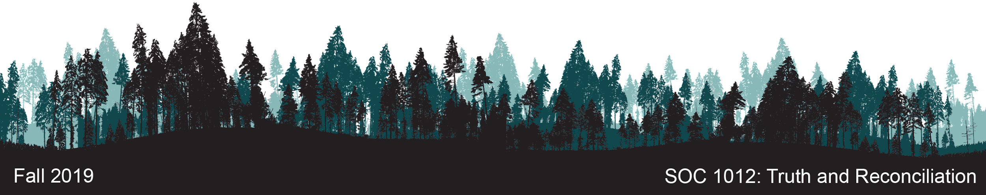

Application One



If you’re in the mood to listen rather than read, [click here to access an audio version](https://drive.google.com/file/d/1Yo36rLOfrmnIGItZiovUwbYKp8VnOifZ/view?usp=sharing) of the following text. Total run time: 9 minutes, 40 seconds.

# 

# Purpose

Here’s an extremely frustrating reality: the majority of Canadians, when asked, know little to nothing about Canada’s Residential School legacy. Whether this is by willful ignorance, the result of a careful rewriting of history, prejudice, or other factors, a change is long overdue. This first assignment invites you to be a part of that change. 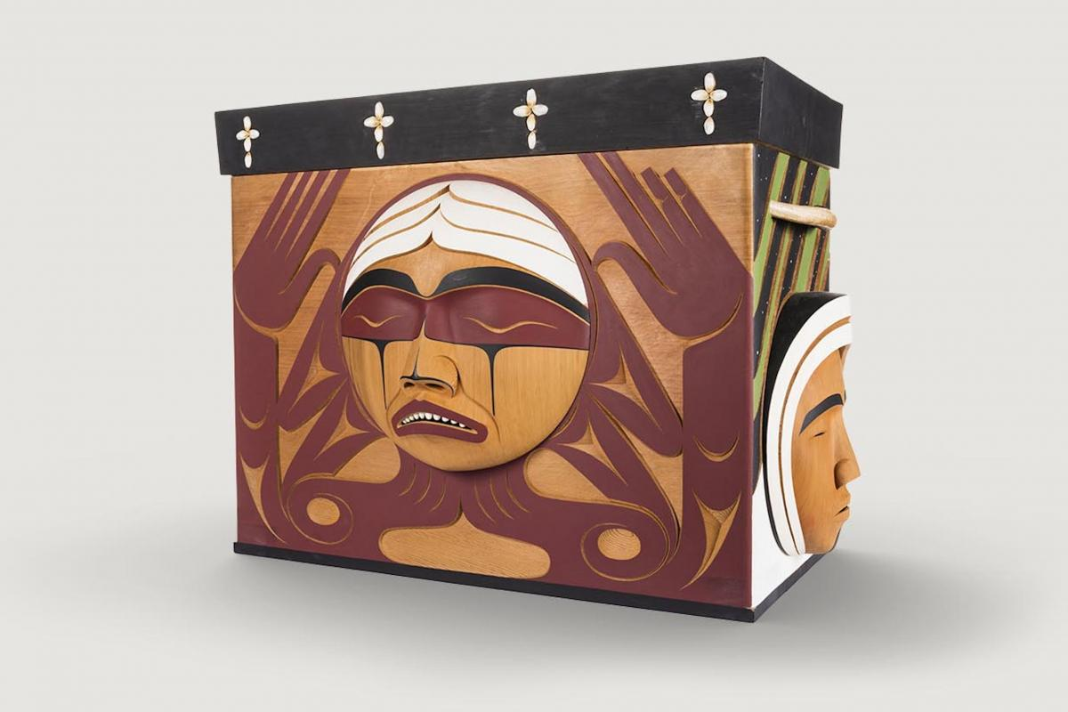

The *Ànikeyàdjimowin ● Understanding Past Events* unit will expose you to many facts related to the Residential School system. While this information will be valuable on a personal level, it will be even more valuable if it is shared with others. Engaging in truth telling contributes to the restoration of dignity for Survivors. It is an act of social justice that calls governments and citizens to acknowledge their responsibility to know. It recognizes that we *all* have a responsibility to know.

In the Algonquin language, the word *mìgiwe* means to give something voluntarily, without expecting anything in return. Know that if you decide to share the truths you’ve learned in this unit, you will become part of a larger collective effort to foster healing in this country, a healing that necessarily requires an understanding and awareness of the traumatic legacy of the Residential School System. 

# 

**“In order to move forward, you have to look back first [...]**

**The truth-telling helped us, and it’s helping Canada”**

* Amanda Andrian, daughter of a Residential School Survivor (Warick, 2017)

# Task

You will produce a creative output that responds to the following prompt:

|  |
| --- |
| **Here’s what everyone should know about the history of Residential Schooling in Canada...** |

# Time Commitment

Plan to spend a total of three hours on this assignment.

# Process

The checklist below should help you develop an amazing end product!

## Identify Your Audience

* Imagine that your assignment is going to be shared with more people than just me. Think about who you are creating for, asking yourself:
  + Who would benefit most from the information you have to share?
  + What is their age, gender, background, location?
  + What format would be most impactful and accessible for them?
* Once you’ve identified your target audience, write it down somewhere so you don’t forget.

## Identify Your Format

* Now that you’ve thought about what your potential audience might like to see, decide on a format for your assignment.
  + Here are some options to consider: poster, infographic, pamphlet, video, Prezi, recorded presentation or conversation, blog post, audio recording, mind map, public performance, Twitterstorm, traditional written assignment (boring), Facebook page, Podcast episode, etc.
  + Honestly, the format you choose isn’t important to me. What is important is that you pick something that makes you excited, encourages your creativity, pushes you (at least slightly) outside of your comfort zone, and helps you communicate and share what you’ve learned in the unit. I’m a techie person, so if you need help with technology, I can probably support you or connect you with someone who can.
  + If you’re really unsure about what format to pick, review the success criteria below. Knowing how I’ll be grading the assignment might help you make a decision. If you’ve got an idea you want to run by me, I’d be really happy to discuss it with you.

## Grow Your Knowledge

* Work through the *Ànikeyàdjimowin ● Understanding Past Events* unit, taking note of any information that you think is worth sharing.
* This will be the “rough work” for your assignment.

## Share Your Knowledge

* Convert your rough work into a more polished final product. Give yourself permission for it to not be perfect - you don’t have endless amounts of time; you have three hours to get it done.
* Complete the Application One Self-Assessment, posted in Moodle.
* Submit your assignment to the Application One assignment dropbox in Moodle.
* If you’re comfortable, celebrate your work by sharing it with others!

# Success Criteria

This assignment is worth 15% of your final mark. To keep it simple, I’ll mark it out of 15. I’m using a passable / solid / exceptional approach to evaluating. Decide for yourself how much time and effort you wish to put into this assignment, and act accordingly! The marks you’ll get for each item are listed on the left. 15 marks = 15%. Remember that your work must conform with Cambrian’s expectations related to Academic Integrity ([review the Policy here](https://cambriancollege.ca/wp-content/uploads/2018/08/Academic-Integrity-Policy-2018.pdf)).

|  |  |
| --- | --- |
|  | **To achieve a passing mark (8/15), submit an assignment that:** |
| **1** | Explicitly indicates where you’re getting your information from by including in-text citations and a complete list of references |
| **2**  **3** | Includes at least four accurate facts (0.5 mark each) related to the factors that contributed to the establishment of the Residential School system by addressing questions such as:   * What assumptions, biases, and prejudices led to the creation of Residential Schools? * What was the intent / purpose of Residential Schools? * Who were the persons responsible for establishing Residential Schools across Canada? |
|
| **4**  **5**  **6** | Includes at least six accurate statements that describe some of the main characteristics of the Residential School system by addressing questions such as:   * Who were the persons responsible for running Residential Schools? * For how long were Residential Schools in operation? When did the first school open? When did the last school close? * How were children taken to Residential Schools? * How many children attended Residential Schools? * What was life like at Residential School? * How many children are estimated to have died at Residential Schools? * What were children allowed and not allowed to do? * What was a child’s day like? * What was the actual educational programming like? * What sorts of abuses occurred at Residential Schools? * How were children’s dietary, health, and wellness needs attended to (or not attended to)? * What sorts of resistance activities did students and parents engage in? * How did children and parents support each other through the era of Residential Schooling? |
| **7**  **8** | Includes at least four accurate facts that convey information related to the creation, management, and closure of Residential Schools by addressing questions such as:   * How many Residential Schools were there in Canada / in Ontario / near us in Sudbury? * Who ultimately ordered Residential Schools to close? * How have Survivors and their families been compensated for the long-term impacts of Residential Schooling? What sort of reparation or restitution has occurred? |
|  | **To achieve a solid mark (11/15), add the following:** |
| **9** | Self-Assessment includes critical thought related to audience identification and awareness. |
| **10** | Self-Assessment includes critical thought related to selecting an appropriate format for the final product. |
| **11** | Self-Assessment demonstrates critical thought related to the potential sharing of the final product. |
|  | **To achieve an exceptional mark (15/15), add the following:** |
| **12**  **13** | The overall submission demonstrates evidence of exploration and discovery that extends beyond the bounds of the course. There is clear evidence that the learner engaged in extensive additional research. |
| **14**  **15** | Demonstrates an exceptional degree of creativity, risk-taking, thought, care. The learner clearly pushed themself outside of their comfort zone. |
|

# Submitting Your Work

# 

1. Complete the Application One Self-Assessment
2. Submit your final product to the Application One dropbox in Moodle
3. Expect to receive feedback from me within a week

## Some Technical Notes

Moodle hates large files. If you opted to produce audio, video, or visual media, and your files are larger than 50 MB, you’ll have trouble uploading those files directly into Moodle. Instead, consider hosting your “stuff” on a third party platform like YouTube or Soundcloud, and sharing the link or links via the dropbox. Cloud-based solutions work well too. You can upload your files into Google Drive, OneDrive, or DropBox and share the link with me via Moodle.

Whatever curveballs technology throws at us, we’ll figure it out.

# Alignment

Completing this assignment will demonstrate your mastery of the following learning objectives:

1.1 Outline the major factors that contributed to the establishment of Residential Schools

1.3 List the main characteristics of the Indian Residential School that made it a "total institution"

2.3 Investigate the creation, management, and closure of Residential Schools

3.4 Design ways to help other Canadians become aware of the history and impact of Residential Schools

# References

Canadian Museum for Human Rights (2019). *Truth and reconciliation*. Retrieved from <https://humanrights.ca/exhibition/truth-and-reconciliation>

Warick, J. (2017). “Truth-telling helped us, and it’s helping Canada,”says residential school survivor’s daughter. CBC News. Retrieved from <https://www.cbc.ca/news/canada/saskatoon/truth-telling-helped-us-helped-canada-residential-school-survivor-1.4346873>